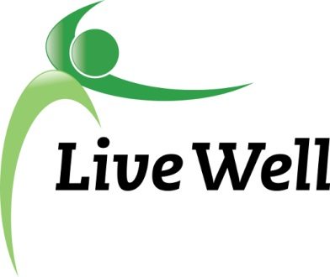
AGENDA

Healthy Food for All Work Group

Lawrence Public Library, Meeting Room A, KS 66044-3701, United States

10:00am – 11:30am, Wednesday, November 8th, 2017

Agenda items | Notes | Action Items
- Introductions
- Announcements | Agenda  - Grant Timeline- Dec. 1st at the latest  - Kansas Double Up Program Update- Lauren Schaumburg, Fair Food Network  - LWL Retreat part 2 update- Gwen  - CDRR Summit and Approved Trainings  - LWL Celebration Breakfast- Friday, December 1st, 8:00am, Lied Center Pavillion  - Leadership Lawrence Community Health Day- Thursday, January 11, 2018, from 8:30 a.m. to 11:15 a.m., at Sports Pavilion Lawrence.  Notes  - Grant awardees will be announced at the Livewell Breakfast on Dec. 1st; however we had an update that the SHSH grant was funded, but the Healthy Pantries initiative was not. Members are encouraged to attend the breakfast if they are able.  - Lauren Schaumburg – update:  - The Fair Food Network now coordinates the Double Up Food Bucks program, working primarily in KS and MO  - Metrics from the 2016-2017 year include $7,000 in food bucks spent at farmer’s markets, $8,000 in SNAP assistance, 146 new customers and 500 transactions  - Lauren has promotional materials and plans to send out quarterly email updates  - This program has been implemented in about 20 states  - They are aiming for more rural and local grocer participation.  - Funding in Kansas comes from the USDA for farmers markets, and Sunflower grants for grocery markets  - For future promotions, it’s important to remember that Food bucks cannot promote SNAP enrollment, however SNAP can promote Food bucks  - HFFA has been requested to attend the Leadership Lawrence Community Health Day on Jan. 11th. Notify leadership if you can attend.  - New priority areas have been announced:  - Access to healthy food and physical activity  - Behavioral Health and Prevention of substance abuse  - Poverty and jobs  - Healthy and affordable housing | What: Notify Kelsey, Christina or Gwen if you would like to participate in the Leadership Lawrence Community Health Day  Who: All members
- Subcommittee Break out session (30 minutes)  Pantry: Sue, Christina, Jessica, Connie, Gwen,  Corner stores: Michelle, Helen, Melissa, Kelsey, | Points of Discussion:  - Continued work on projects  - Action items moving forward-Specific assignments.
- Subcommittee report to group | Agenda  Small report back on discussion and action steps moving forward (this will help us capture information in notes)  - Send goals & objectives to Kelsey  Notes  Healthy Pantries:  - There were questions about the grant application from the foundation  - We reviewed the project for new members  - For next time, proof the survey and bring back for the next meeting; review guidelines  - Partnership opportunities with Harvesters regarding their pantry lists and evaluation system  - Find ways to integrate breastfeeding as first food  SHSH:  - The next stage is to move forward in the community and meet with community members  - Data collection will include KU interns to help with surveying at bus stops, local neighborhoods, etc.  - Additional survey data will be collected in store and through survey monkey | What: Review/proof the survey and bring back to next meeting; review guidelines  Who: Healthy Pantry members
- Additional updates/ Accomplishments forms | Agenda  - KU committee work and SNAP Training  - Meeting location for next meeting?  Notes  - DCF has a new computer system and some clients may have fallen through the cracks. If anyone needs assistance, contact 785-832-3707 for customer affairs.  - Telephone signature for SNAP enrollment has not happened yet – since passing, implementation has been difficult.  - Meeting next time will be Dec. 13th at the Library  - Need nominations for Health Champion for the Livewell Breakfast. Submit suggestions to Kelsey.
- Adjourned

