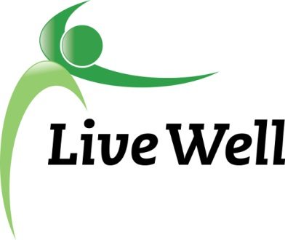
AGENDA

Healthy Food for All Work Group

Lawrence Public Library, Meeting Room C, KS 66044-3701, United States

10:00am – 11:30am, Wednesday, December 13th, 2017

Agenda items | Notes | Action Items
- Introductions
- Announcements | - SHSH Grant Awarded  - Healthy Pantry Project beginning to look for new grant opportunities.  - Suggestions?  - LWL Retreat part 2 updates- Gwen  - CDRR Summit and Approved Trainings  - The annual Chronic Disease Risk Reduction (CDRR) Summit will be in Wichita January 31 - February 2, 2018.  - National Rural Grocery Summit  - National Rural Grocery Summit, June 25-26, 2018 at the Hilton Garden Inn in Manhattan, Kansas.  - Leadership Lawrence Community Health Day- Thursday, January 11, 2018, from 8:30 a.m. to 11:15 a.m., at Sports Pavilion Lawrence.  - Intern update  - Brainstorm projects
- Subcommittee Break out session (30 minutes)  Pantry: Sue, Christina, Jessica, Connie, Gwen, Liz  Corner stores: Michelle, Helen, Melissa, Kelsey, Brooke | Points of Discussion:  - Continued work on projects  - Intern projects-submit to Kelsey  - Action items moving forward-Specific assignments.
- Subcommittee report to group | Small report back on discussion and action steps moving forward (this will help us capture information in notes)  - Send goals & objectives to Kelsey
- Additional updates/ Accomplishments forms | - Meeting location for next meeting?
- Adjourned

