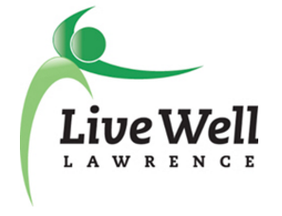

Healthy Food for All
Accomplishments
1/1/13-6/30/17

Table of Contents
Document Overview……….…………………………….……………………………………….2
LiveWell Goal Areas…...…...………………………………………………………………….....3
Access to Healthy Foods……………………………………………….…………….……………4
Cumulative Community Changes by Quarter……………………………….………….…4
Annual Cumulative Community Changes by Month……………….…….…………….…5
Behavior Change Strategies…………………………….………………………….……...6
Target Groups for Behavior Change……………………………………………….……...7
Sector Most Affected……………………………………………….……………………..8
City Where Event Took Place…………………………………………….………………9
Duration of Services and Community Changes………………………...………………..10
Douglas County Food Assistance Metrics……………………………………………………….11
Activity Type Table and Definitions………………………………………………..…………...12
Accomplishment Listing……………………………………………….………………………...12

Document Overview
This document presents data recorded in the Community Check Box documentation system, primarily for Healthy Food For All (HFFA) over the previous year; as well as in the context of the past 4.5 years and in relation to other priority goals for the LiveWell Coalition. Data are presented in graphs and tables to communicate the rate and distribution of the initiative’s efforts and create an opportunity for learning and reflection. In addition to looking for accuracy and completeness, the following are questions to guide interpretation of data and reflection:

LiveWell Goal Areas
Questions
- What are we seeing?

- What does it mean?

- Implications for adjustment?
Accomplishments by Priority or Goal
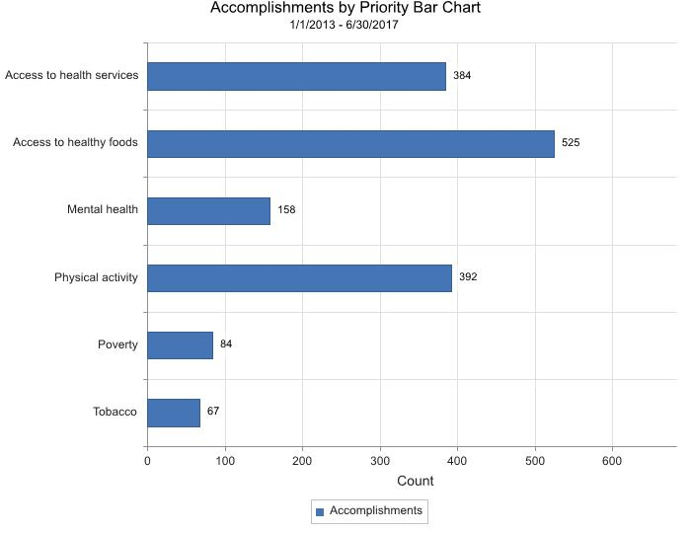
- Over the previous 4.5 years, the priority area of access to healthy foods shows the highest number of accomplishment entries (N=525); Thirty-three percent of all accomplishments were primarily aligned with the access to healthy foods goal.
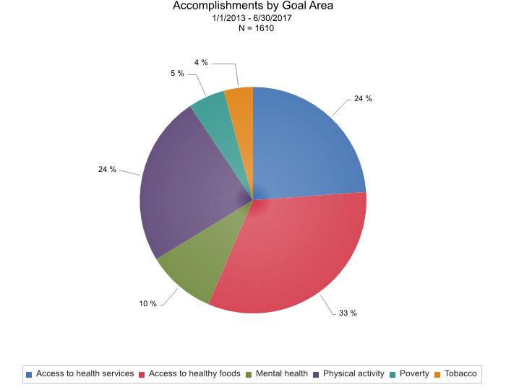
Access to Healthy Foods
Cumulative Community Changes by Quarter
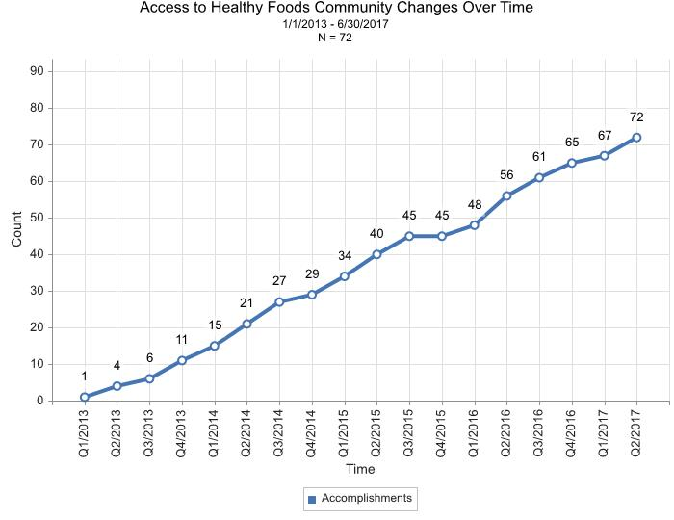
Quarterly Community Change Totals

Range = 0-8
Mean = 3.77
Median = 4.5
Mode = 5
- The quarterly rate of community changes (new or modified programs, policies, or practices) over the last 4.5 years is fairly steady, with a visible decrease to zero during October – December of 2015.

Annual Cumulative Community Changes by Month
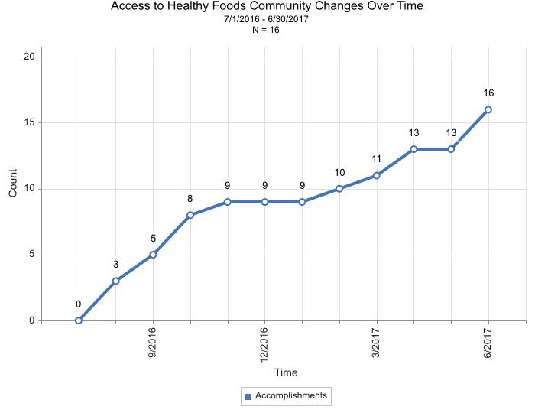
Monthly Community Change Totals

Range = 0-3
Mean = 1.25
Median = 1
Mode = 0
- The monthly rate of community changes over the last year shows a steep increase from July through October of 2016, tapers off through January of 2017, and then increases with some variability over the last 5 months.

Behavior Change Strategies 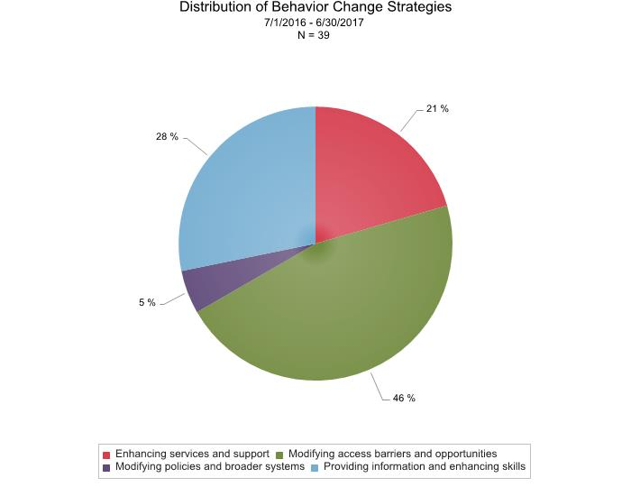
Questions
- What are we seeing?

- What does it mean?

- Implications for adjustment?
- Thirty-nine accomplishments were documented using a behavior change strategy, and approximately half of those reported modifying access, barriers, or opportunities (N=18) related to the goal of accessing health foods. The next most frequently used strategy was providing information (N=11), followed by enhancing services and supports (N=8)), and then modifying policies and broader systems (N=18).
Strategy | HFFA Examples
Providing information and enhancing skills | The Sunrise Project had a Winter Pruning Workshop to teach the basics of winter pruning for increasing fruit tree health and productivity.
Modifying access, barriers, and opportunities | Harvesters partnered with K-State Research and Extension to provide meals at the Douglas County Fair. This partnership provided suppers for four days during the fair.
Enhancing services and supports | Harvesters trained the KU Center for Community Outreach Daily Bread student volunteers about food stamp application (with information for college student barriers) to help pantry participants with SNAP applications.
Modifying policies and broader systems | The Douglas County Food Policy Council published a public draft of a Local Food System Plan online and available for public comment.
Changing consequences
Target Groups for Behavior Change
Questions
- What are we seeing?

- What does it mean?

- Implications for adjustment?
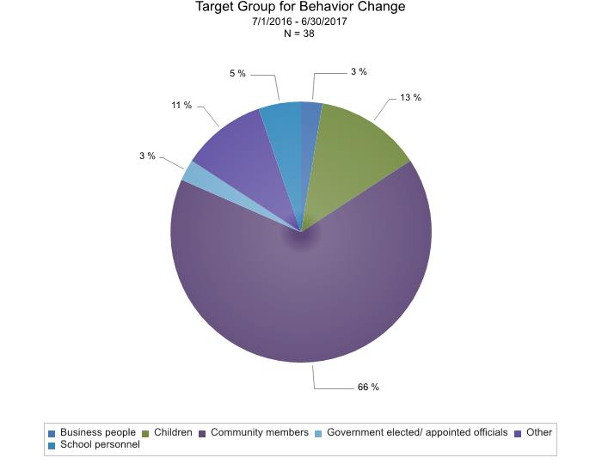
- Thirty-eight entries specified a target group for behavior change efforts, of which 66% documented community members as the target group (N=25). The second most common group was children (N=5).
- Vulnerable populations (N=1), Farmers (N=1) and students at KU events (N=2) were mentioned in descriptions where other (N=4) was selected.
- Categories that were not selected include: Parents/caregivers, employers, child care providers, food and beverage providers, health care providers, media, or parks and recreation personnel.

Sector Most Affected
Questions
- What are we seeing?

- What does it mean?

- Implications for adjustment?
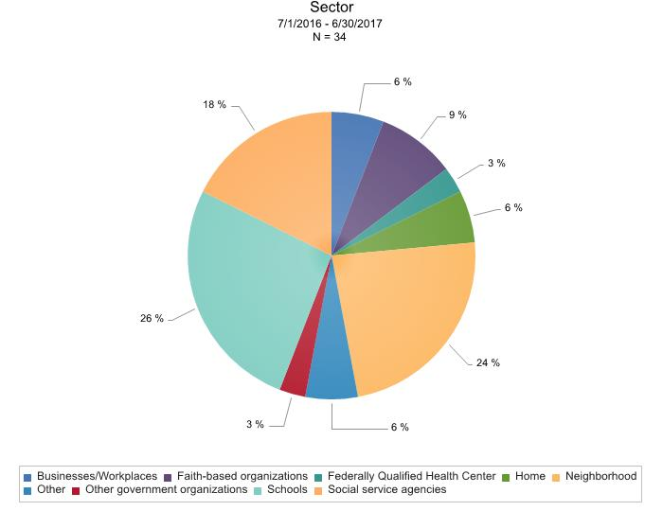
- Thirty-four accomplishments selected a sector most affected by the event or activity.
- Schools were most affected (N=9), followed closely by neighborhoods (N=8), then social service agencies (N=6), and fourth was faith-based organizations (N=3).
- For events that selected other (N=2) as the sector involved, the activities were: distributing free meals at the county fair and The Healthy Food for All Work Group voting on new priorities for 2016-2017.
- Categories that were not selected include: Child care/preschools, criminal justice, food retailers, local and state health departments, hospitals, media, parks and recreational department, primary care offices, transportation, and youth organizations.

City Where Activity/Event Took Place
Questions
- What are we seeing?

- What does it mean?

- Implications for adjustment?
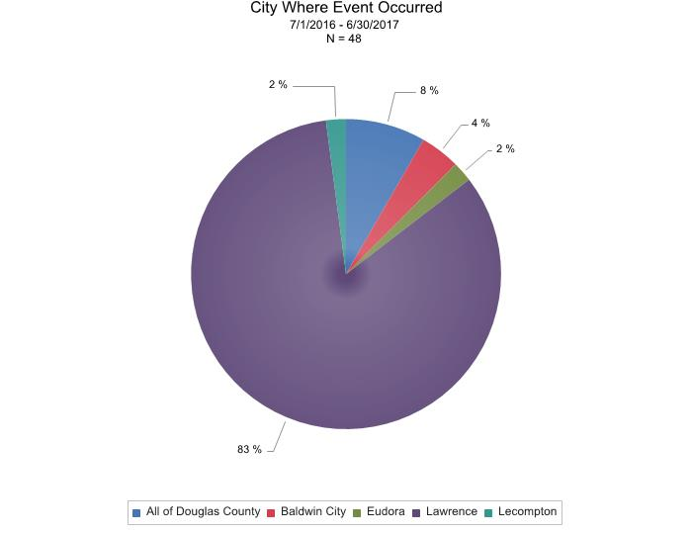
- Forty-eight entries specified the city where the event or activity took place, with 83% of those occurring in Lawrence (N=40). The next most common location was all of Douglas County (N=4). Additional locations for events and activities were: Baldwin City (N=2), Eudora (N=1), and Lecompton (N=1).
- When looking only at entries coded as services and community changes, there are 31 entries: 27 in Lawrence (87%), 2 in all of Douglas County (6%), 1 in Baldwin City (3%), 1 in Lecompton (3%), and zero in Eudora.

Duration of Services and Community Changes
Questions
- What are we seeing?

- What does it mean?

- Implications for adjustment?
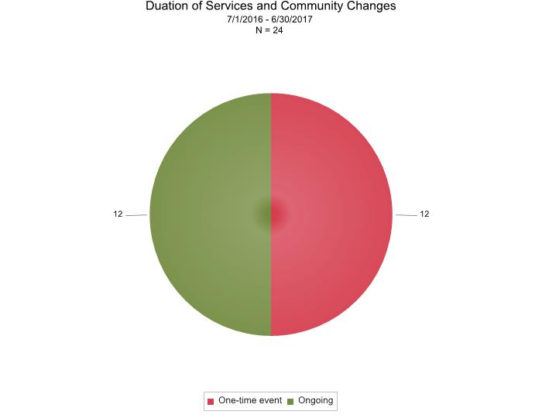
- Out of 24 service and community change events that selected a duration, 12 activities were ongoing and 12 were one-time events.

Douglas County Food Assistance Metrics
Questions
- What are we seeing?

- What does it mean?

- Implications for adjustment?

- From 2014 to 2015, there is decreasing trend for average monthly households, adults, and children enrolled in Douglas County Food Assistance.
- From 2014 to 2016, there is a decreasing trend for average monthly total persons enrolled in Douglas County Food Assistance.

- From 2014 to 2016, there is decreasing trend for annual service dollars for Douglas County Food Assistance.
Accomplishment Listing

Activity Type | Code | Definition
Community/System Change | CC | A new or modified program, policy, or practice in the community, system, or organization
Community Action | CA | Action to bring about a specific new or modified program, policy, or practice in the community or system.
Development Activity | DA | Actions taken to prepare or enable the group to address its goals and objectives.
Services Provided | SP | Delivery of information, training, or other valued goods or activities to members of the community.
Media Coverage | M | Conveying information about the initiative and its accomplishments to the community through media.
Resources Generated | RG | Acquisition of resources for the initiative through grants, donations, or gifts in kind.
Other | O | Items for which no code or definitions have been created
*Rule for double coding: The only double code that is used is Community Change/Services Provided (CC/SP), for the first time a service is provided in the community.

Date | Description of Activity/Event | Code(s):
6/28/2017 | "The Food System Plan was unanimously adopted by the Douglas County Commission on June 28. The City of Lawrence will consider the plan for adoption on its July 11 Consent Agenda...The final plan will be subsequently incorporated by reference into the revised comprehensive plan (in development). The plan will then serve as the guiding document for the Council, staff, and the Douglas County community to build a stronger local food system." | Community Change (CC)
6/17/2017 | The Sunrise Project (http://www.sunriseprojectks.org/) had their grand opening to the community on June 17, 2017 from 5-8 PM.  The community was invited to see the community kitchen, workshop space and offices, and learn about what the initiative had started and future plans. Food was catered by Culinaria, there was music and activities for all ages, and there was a raffle. | Services Provided (SP)
6/14/2017 | On July 14, 2017 BOOM COMICS hosted a Free Comics and Games event with free lunches provided by Lawrence Public Schools Food Service for ages 1-18 from 11:30 AM - 12:30 PM.  The flyer states Fuel Up 4 Summer Food That's In when School is Out. The website FUELUP4SUMMER.COM was also provided on the flyer. | Services Provided (SP)
6/10/2017 | The Sunrise Project had a free self-guided Lawrence Food Garden Tour of personal, community, and school gardens throughout Lawrence, Kansas on 6/10/17 from 9 AM - 12 PM. The aim was to showcase the diversity of food gardens within Lawrence and had gardeners on site to give tours and share garden knowledge and inspiration. | Services Provided (SP)
6/1/2017 | Helen Schnoes, Douglas County Food Systems Coordinator, received permission from County Administrator Craig Weinaug to serve as Chair Elect of the Healthy Food for All Work Group. | Development Activity (DA)
6/1/2017 | Heartland Community Health Center recently added a commercial glass two-door refrigerator to its food pantry, thanks to a LiveWell Community Wellness Grant through the Douglas County Community Foundation. The refrigerator increased storage capacity of fresh produce, dairy and eggs by 34 percent. "It's great because in the past we've gotten some bigger donations of produce before - like 60-plus pounds - that we weren't able to properly store." Outreach and Enrollment Specialist Brandy Ordiway said. "Some of the food would end up going bad." Heartland provides with families about a week's worth of groceries for healthy meals every month. Families can receive food once per month. Food is collected on a rotating basis from groups throughout the community, including churches, clubs and service organizations. | Community Change (CC)
5/24/2017 | "Douglas County, KS received the Community Health Champion award at the 2017 Kansas State of Wellness Symposium. Douglas County has utilized their Food Policy Council to create a thriving local food system. The County has worked hard to recruit diverse partners including producers, consumers, hunger organizations, local government, non-profits, and private sector organizations to solicit feedback. The have also enhanced the food system by developing a food hub, SNAP Double-Up program at farmers' markets, community gardens, and many other innovative partnerships. Through their engagement and partnership building efforts, they have cultivated a community culture that is supportive of healthy, locally grown foods." - Kansas Alliance for Wellness Facebook post | Media (M)
5/6/2017 | Sunrise Project hosted its annual Plant Sale on Saturday, April 22nd and Saturday, May 6th, 1-4pm at the Sunrise site: 1501 Learnard Ave. Organic plants included: rhubarb, kale, herbs, chard, lettuce, nasturtium, and native plants. Plant prices will ranged from $3-$4. There was also organic fertilizers and worm castings. Proceeds supported the mission to connect people to good food, the environment and community. | Services Provided (SP)
4/23/2017 | KU Football partnered to host a sack lunch event to promote the summer feeding program. This event was held Sunday, April 23rd 1 to 3 p.m. at the Lawrence Library Lawn. | Services Provided (SP)
4/22/2017 | Sunrise Project held an organic transplant sale on Saturday, April 22nd 1 to 4 p.m. Promotion of gardening and eating fresh, healthy, local food. | Services Provided (SP)
4/14/2017 | Elizabeth Keever of Just Food created Healthy Pantry posters/ fliers/ promotional materials that were presented to and approved for use by the group. These materials will now be distributed to groups assisting with food drives to promote donation of healthy items.  LDCHD will use a portion of the remaining Kansas Health Foundation funding to purchase quarter sheet printing and posters of materials. Will also look into ordering window clings as a way to honor participating pantries (will include logos from the bottom corner of new promotional materials). Need to also make social media versions of the materials. | Community Change (CC)
4/12/2017 | Just Food launched Pots and Pan-try, a kitchen supply pantry. "We believe that when our families have the tools necessary, they will cook at home more frequently and the nutritional value of those foods will increase," Executive Director Elizabeth Keever said. "This will result in healthier Douglas County residents spending less money on eating out and more time cooking healthy food at home." Just Food is accepting donations of gently-used and new kitchen supplies during regular donation hours: 1 p.m. to 7 p.m. Mondays; and 9 a.m. to 4 p.m. Tuesday through Friday. | Community Change (CC)
4/8/2017 | The Sunrise Project had a Grafting Workshop Saturday, April 8th from 12 p.m. to 3 p.m. at Lawrence Community Orchard. The class begins with the science behind grafting and then hands-on practice making grafting cuts. Finally, students graft onto rootstocks in the nursery. The goal is that students walk away from the workshop with the skills and confidence to do their own grafting in the future. A suggested $25 donation, but no one turned away due to lack of funds. For safety concerns, must be 18 years of age or older to attend this workshop. | Services Provided (SP)
4/1/2017 | Developed a Healthy Pantries pantry self-assessment for pantries to use to share their current practices and to be used as a prompt for potential changes to be implemented. | Development Activity (DA)
4/1/2017 | Developed a Healthy Pantries pantry self-assessment for pantries to use to share their current practices and to be used as a prompt for potential changes to be implemented. | Development Activity (DA)
3/12/2017 | The Sunrise Project had an event:  "Tree Planting Day! Lawrence Community Orchard is expanding this year! You're invited to come help plant fruit trees at the new space. Sunday, March 12th starting at noon, we'll be planting trees, installing signage, enjoying refreshments and getting to know our neighbors. The orchard addition is located directly on Burroughs Creek Trail at 13th and Oregon. There is no parking on 13th, so please park along nearby residential streets or walk/bike. A donation of $30 will help us purchase a tree. If you wish to contribute, bring cash or a check to the event or donate at www.sunriseprojectks.org. However, the event is free and open to all. See you there!" | Services Provided (SP)
3/11/2017 | The Sunrise Project had a Winter Pruning Workshop on 3/11/17 from 12 PM - 3 PM at the Lawrence Community Orchard.  "Would you like to learn the art of pruning? In this hands-on workshop you will learn the basics of winter pruning in order to increase fruit tree health and productivity.  A $25 donation for the class is suggested, but no one will be turned away for the lack of funds.  Instructor: Skyler Adamson, Lawrence Fruit Tree Project Coordinator" | Services Provided (SP)
3/1/2017 | Cordley Elementary School expanded its school garden, thanks to a LiveWell Community Wellness Grant through the Douglas County Community Foundation. In early March, Cordley's Farm to School Committee installed three new garden beds and planted two Asian pear trees. "This initiative represents an important opportunity for the children and community at Cordley because these gardens and trees provide an unforgettable learning experience that many students and families might otherwise be unable to access," said Erin Besson, a parent who helps coordinate the Farm to School committee. "The gardens are a particularly valuable resource because they expose the children to the process of growing actual food." | Community Change (CC)|Services Provided (SP)
2/23/2017 | Shelly Paul from Harvesters came to train the KU Center for Community Outreach group Daily Bread student volunteers about food stamp application (with specific information for college student barriers). The idea is for volunteers to help pantry participants with SNAP applications. There were 8 participants in the training. | Community Change (CC)
2/22/2017 | Kansas Appleseed hosted an event in Topeka on February 22, 2017 from 10:00 AM - 1:00 PM at the Shawnee County Public Library (Topeka, KS 66604). The aim of the event was to have an in-depth conversation about the state of the Food Assistance program in Kansas (i.e., what is working and not working with the application process, denials, recertications and appeals). The agenda included: Introductions, a presentation for The Future of SNAP under a New Presidential Administration, a group discussion, and lunch. | Development Activity (DA)
2/13/2017 | Focus group held at at Just Food February 13th, 10-11:30am with Harvesters and Just Food pantry partners. Well-attended, included representatives from Lecompton food pantry, Trinity food pantry, Salvation Army, and other pantries.  Highlights from the focus group:  - Growing demand for healthy food. Shoppers are savvy and know what are high/low value foods.  - It already takes a lot for people to run a food pantry, it's hard to do anything in addition  - Barriers - lack of space, food supply, human power  - Kelsey handed out the sheets where pantries could mark off what they have done or worked on as "low hanging fruit"  - The continuing theme was "we already do so much," it will be hard to do something else or anything in addition  - Sue shared it could be helpful to have someone come in to Trinity to identify and help work to identify what issues could be encountered. Group decided to do this as a pilot of the concept.  - Testing out the process at Trinity of healthy food for all advocate  - How to make staples more healthy and specific cuts of meats that clients may not know what to do with, but how can we do more with less and try to make those things healthy  - Addressing food allergies is difficult with foods like strawberries  - Discussion of need for cultural foods and how to handle that  - Need for non-food items also came up (e.g., hygiene, kitchen items)  - To make pantry self-assessment less intimidating, could organize points list by items relevant to different size pantries  - Perhaps eliminate points system users see and move to checks to eliminate burden of system on users? | Development Activity (DA)
1/23/2017 | Charlie Bryan and Alison Dishinger, both members of the Downtown Grocery Committee, were interviewed by Hank Booth on 1320 KLWN's According to the Record with Hank Booth show. The purpose of the interview was to promote awareness of the existence and impact of the food desert areas in Lawrence. A podcast of the interview is available at https://soundcloud.com/1320klwn/attr-1-23-17#t=17:43 | Media (M)
1/23/2017 | The Douglas County Food Policy Council (DCFPC) published a public draft of a Local Food System Plan. The draft plan is available online for public comment until February 21, 2017. Public comment will also be received at the February DCFPC meeting on February 27, 2017. | Community Action (CA)
1/20/2017 | Staff from the Lawrence-Douglas County Health Department and the KU Work Group for Community Health and Development provided overviews of three reports - (1) Local Public Health System Assessment, (2) Community Health Issues Survey, (3) Community Health Data/Statistics Report -- to the Steering Committee overseeing the development of the next Community Health Assessment and Plan. The Steering Committee was asked to reflect on these reports and to provide recommendations to the staff team on issues for additional investigation. A second phase of data collection will be used to provide insight to the Steering Committee when they frame priority issues for the next Community Health Plan. | Development Activity (DA)
1/19/2017 | Members of the Downtown Grocery Core Group met to continue collaborating with the goal of eradicating the food deserts affecting northeast Lawrence. | Development Activity (DA)
1/12/2017 | Members of the Downtown Grocery Core Group met to continue collaborating with the goal of eradicating the food deserts affecting northeast Lawrence. | Development Activity (DA)
1/11/2017 | On January 11th, the Lawrence USD 497 Farm to School Team held the 2nd annual Farmer's Meeting to discuss purchasing processes, delivery logistics, and the future of farmer participation in the Lawrence USD 497 Farm to School Program. In addition recognizing the 6 farmers who are currently selling their produce, Lawrence USD 497 welcomed farmers who are interested in selling to our schools as well as food service representatives from other districts in Douglas County. | Services Provided (SP)
1/5/2017 | Members of the Downtown Grocery Core Group met to continue collaborating with the goal of eradicating the food deserts affecting northeast Lawrence. | Development Activity (DA)
1/3/2017 | The Lawrence Journal-World published an article about a presentation by members of the Downtown Grocery Committee to the Lawrence City Commission about the food desert impacting northeast Lawrence and the proposal to build a grocery store at 700 New Hampshire Street, the site of the former Borders bookstore building. Members of the committee presented an update on their work during the Jan. 3, 2017 Lawrence City Commission meeting. | Media (M)
1/3/2017 | Members of the Downtown Grocery Committee provided an update to the Lawrence City Commission on progress to address the Lawrence food desert in northeast Lawrence. The update included a presentation by Lawrence-Douglas County Health Department staff on the map and data related to the Lawrence food desert areas. The link to the Lawrence City Commission agenda is https://assets.lawrenceks.org/assets/agendas/cc/2017/01-03-17/01-03-17_cc_agenda.html | Community Action (CA)
1/3/2017 | 6 News Lawrence aired a story about efforts by the Downtown Grocery Committee to educate the public and the Lawrence City Commission about the food desert impacting northeast Lawrence and the proposal to build a grocery store at 700 New Hampshire Street, the site of the former Borders bookstore building. Members of the committee will present an update on their work during the Jan. 3, 2017 Lawrence City Commission meeting. News story link: http://www.6newslawrence.com/news/local-news/21221-city-commissioners-to-hear-downtown-grocery-store-project | Media (M)
1/2/2017 | The Lawrence Journal-World published a story about a Lawrence City Commission presentation by members of the Downtown Grocery Committee scheduled the Jan. 3, 2017. Members of the committee are expected to update the Lawrence City Commission on their efforts to address the food desert impacting northeast Lawrence by establishing a grocery store at 700 New Hampshire, the site of the former Borders bookstore building. | Media (M)
12/29/2016 | Members of the Downtown Grocery Core Group met to continue collaborating with the goal of eradicating the food deserts affecting northeast Lawrence. | Development Activity (DA)
12/22/2016 | Members of the Downtown Grocery Core Group met to continue collaborating with the goal of eradicating the food deserts affecting northeast Lawrence. | Development Activity (DA)
12/22/2016 | Members of the Downtown Grocery Core Group met to continue collaborating with the goal of eradicating the food deserts affecting northeast Lawrence. | Development Activity (DA)
12/20/2016 | The Lawrence Journal-World editorial staff published an editorial stating a grocery store in downtown Lawrence should be a priority for the Lawrence City Commission in order to address the Lawrence food desert. The editorial was published online and in the Dec. 20, 2016 print edition. | Media (M)
12/19/2016 | The Lawrence Journal-World published a story on the impact of the Lawrence food deserts. Lance Fahy, member of the Downtown Grocery Committee and Pinckney neighborhood resident, was featured in the story. Also, the story included data and a map of the Lawrence food desert areas developed by the Lawrence-Douglas County Health Department. Story was published in print on front page of the Dec. 19, 2016 issue. | Media (M)
12/15/2016 | Members of the Downtown Grocery Core Group met to continue collaborating with the goal of eradicating the food deserts affecting northeast Lawrence. | Development Activity (DA)
12/8/2016 | Members of the Downtown Grocery Core Group met to continue collaborating with the goal of eradicating the food deserts affecting northeast Lawrence. | Development Activity (DA)
12/7/2016 | Lawrence Public Schools / USD 497 submitted a multi‐district planning grant application for the FY 17 USDA Farm to School Grant Program. Eudora and Baldwin City public school districts submitted letters of support for the proposal to show their willingness to collaborate in the multi‐district planning process. | Development Activity (DA)
12/1/2016 | Members of the Downtown Grocery Core Group met to continue collaborating with the goal of eradicating the food deserts affecting northeast Lawrence. | Development Activity (DA)
11/18/2016 | The Healthy Food for All Work Group awarded the Culture of Health Action Award to Cornelius Bell during the LiveWell Lawrence Celebration Breakfast. Mr. Bell is recognized for his efforts as the Site Coordinator for Communities in Schools of Mid-America at Liberty Middle School. Cornelius is an incredible advocate for his students. He ensures that students with little to no access to foods on the weekend go home with non-perishable meals and food for the weekend. He makes sure his students who qualify for breakfast are there in the morning, and if they miss or are late he takes them a snack before or after class to be sure they eat breakfast. Cornelius coordinates a wellness fair during parent/teacher conferences in which parents and students engage with organizations like the health department, El Centro and Just Food to help connect parents and students to community resources. | Community Change (CC)|Services Provided (SP)
11/17/2016 | Members of the Downtown Grocery Core Group met to continue collaborating with the goal of eradicating the food deserts affecting northeast Lawrence. | Development Activity (DA)
11/10/2016 | Members of the Downtown Grocery Core Group met to continue collaborating with the goal of eradicating the food deserts affecting northeast Lawrence. | Development Activity (DA)
11/3/2016 | Members of the Downtown Grocery Core Group met to continue collaborating with the goal of eradicating the food deserts affecting northeast Lawrence. | Development Activity (DA)
10/28/2016 | The University of Kansas hosted their third Annual Hunger Summit for faculty, staff, students,and community members to identify opportunities to address food and nutrition security through research and outreach. Included in the summit was a keynote presentation by Representative John Wilson, campus and community presentations on Double Up Food Bucks, a survey of hunger in KU students and faculty, and other community topics, a presentation on The Community Tool Box as tool for change, and breakout discussions surrounding causes of hunger. | Services Provided (SP)
10/28/2016 | KU hosted an action-oriented summit of faculty, staff, students and community members to identify opportunities to address food and nutrition security through research and outreach.  The tentative schedule for the day includes:  9:00 AM - Registration  9:30 AM - Welcome and introductions  9:45 AM - Keynote Presentation: Representative John Wilson  11:00 AM - Campus and Community Presentations: Turning Research into Action  12:00 PM - Lunch*  12:45 PM - Tools for Action: The Community Tool Box  1:15 PM - Breakout Discussions  2:30 PM - Wrap-up | Community Change (CC)
10/27/2016 | Members of the Downtown Grocery Core Group met to continue collaborating with the goal of eradicating the food deserts affecting northeast Lawrence. | Development Activity (DA)
10/26/2016 | Harvesters hosted a "Doing Good is Good for business" panel discussion.  Description: The world of business is changing for the good: creating space for social entrepreneurs and others who don’t just want to earn a profit, but to do something good for other people and the planet. Building sustainability within business models can have a huge impact on the Lawrence community at large. Join us for a panel discussion on bettering our community through business. Hear local perspective on how changing the business model gives back to the community, and makes space to provide resources for those in need. | Community Change (CC)
10/24/2016 | As a part of hunger Awareness Month Activities Watkins Health Services and KU Dining hosted a healthy Eating on a budget cooking class for students. | Community Change (CC)
10/20/2016 | Members of the Downtown Grocery Core Group met to continue collaborating with the goal of eradicating the food deserts affecting northeast Lawrence. | Development Activity (DA)
10/16/2016 | The University of Kansas hosted "Stuff the Bus" where members of the campus and Lawrence community were invited to donate non-perishable items. All items collected were donated to Just Food of Douglas County. | Resources Generated (RG)
10/13/2016 | Members of the Downtown Grocery Core Group met to continue collaborating with the goal of eradicating the food deserts affecting northeast Lawrence. | Development Activity (DA)
10/6/2016 | Members of the Downtown Grocery Core Group met to continue collaborating with the goal of eradicating the food deserts affecting northeast Lawrence. | Development Activity (DA)
10/5/2016 | The University of Kansas hosted a presentation by Robert Egger, the founder and CEO of L.A. Kitchen, a program that recovers food that would otherwise go to waste while providing employment for youth leaving foster care, returning citizens and the newly housed. | Services Provided (SP)
10/5/2016 | The Faculty and Staff Wellness Lunch and Learn at the University of Kansas included a discussion on hunger in our community and a cooking demonstration. | Services Provided (SP)
10/1/2016 | Throughout the month of October, KU Fights Hunger collected non-perishable and monetary donations on the Lawrence Campus to benefit Just Food and their 40+ partner agencies in Douglas County. | Resources Generated (RG)
10/1/2016 | During Late Night at the Phog, fans were encouraged to bring nonperishable food items, which Kansas Athletics donated to Just Food of Douglas County. Nonperishable food and monetary donations were also accepted throughout the day supporting Just Food. | Resources Generated (RG)
9/29/2016 | Members of the Downtown Grocery Core Group met to continue collaborating with the goal of eradicating the food deserts affecting northeast Lawrence. | Development Activity (DA)
9/28/2016 | KU Fights Hunger participated and the Watkins Health Services annual wellness fair. Education on Hunger Awareness month activities, community and campus food assistance resources, and facts on hunger in our community was shared with students. | Services Provided (SP)
9/28/2016 | University of Kansas students participated in a food drive/ CANstruction competition to support the KU food pantry the Campus Cupboard, and Harvesters Food bank. Teams worked on their creation during the morning before votes were taken in the afternoon for the best structure. | Resources Generated (RG)
9/22/2016 | Members of the Downtown Grocery Core Group met to continue collaborating with the goal of eradicating the food deserts affecting northeast Lawrence. | Development Activity (DA)
9/15/2016 | Members of the Downtown Grocery Core Group met to continue collaborating with the goal of eradicating the food deserts affecting northeast Lawrence. | Development Activity (DA)
9/8/2016 | Members of the Downtown Grocery Core Group met to continue collaborating with the goal of eradicating the food deserts affecting northeast Lawrence. | Development Activity (DA)
9/1/2016 | Just Food, the community food bank of Douglas County, expanded their Just Cook classes. In partnership with Baldwin City Recreation, they are offering an after school cooking program to area youth. This program will teach healthy and kid friendly recipes. | Community Change (CC)|Services Provided (SP)
9/1/2016 | Members of the Downtown Grocery Core Group met to continue collaborating with the goal of eradicating the food deserts affecting northeast Lawrence. | Development Activity (DA)
9/1/2016 | Just Food, the community food bank of Douglas County, expanded their Just Cook classes. In partnership with Lecompton United Methodist Church, they are teaching members of the church and the community how to cook healthy meals for under $2 a serving. | Community Change (CC)|Services Provided (SP)
8/25/2016 | Members of the Downtown Grocery Core Group met to continue collaborating with the goal of eradicating the food deserts affecting northeast Lawrence. | Development Activity (DA)
8/20/2016 | Harvesters partnered with K-State Research and Extension to provide meals at the Douglas County Fair. The city served lunches, and this partnership between Harvesters and Extension provided afternoon/evening suppers. This was available for four days during the fair. The first two days, approximately 40 kids were served each day. The last two days, approximately 20 kids were served each day. Shelf-stable meals were available for kids through the summer feeding program. Harvesters also provided brown bags through a program called "Give Lunch" so adults could grab a meal if they needed as well. | Community Change (CC)|Services Provided (SP)
8/19/2016 | Harvesters, the Community Food Network, provided training in SNAP application assistance to 10 volunteers from various community organizations. Volunteers learned about SNAP (the Supplemental Nutrition Assistance Program), eligibility requirements, how to fill out the application in paper and digital format, and ways to maximize SNAP spending. | Services Provided (SP)
8/18/2016 | Members of the Downtown Grocery Core Group met to continue collaborating with the goal of eradicating the food deserts affecting northeast Lawrence. | Development Activity (DA)
8/13/2016 | Harvesters, the regional food back for northwestern Missouri and northeastern Kansas, established a new mobile pantry in Lawrence. Mobile food pantry distributions are typically drive-through, consisting primarily of fresh produce, dairy items, and bakery items. They are open to anyone in need of food. No proof of income or address is required. | Community Change (CC)|Services Provided (SP)
8/12/2016 | The Healthy Food for All Work Group met during their regularly scheduled monthly meeting to discuss and vote on new priorities for 2016-2017. They voted and passed a Policy priority for establishing healthy food pantries and feeding sites to assure healthy food options are available to vulnerable populations. This includes:  - Promoting implementation of choice based systems,  - Promoting SNAP enrollment,  - Increasing percentage of healthful foods offered in pantries,  - Increasing capacity for storing and distributing healthy food options,  - Developing marketing materials for healthier donations and food drives,  - Recognition of healthy pantry efforts with the FuelGood brand. | Development Activity (DA)
8/12/2016 | The Healthy Food for All Work Group met during their regularly scheduled monthly meeting to discuss and vote on new priorities for 2016-2017. They voted and passed an Advocacy priority for supporting the Downtown Grocery project. This includes advocating for a downtown grocery store when it is pertinent and timely to do so as well as getting letters of support from community organizations for the project. | Development Activity (DA)
8/11/2016 | Members of the Downtown Grocery Core Group met to continue collaborating with the goal of eradicating the food deserts affecting northeast Lawrence. | Development Activity (DA)
8/4/2016 | Members of the Downtown Grocery Core Group met to continue collaborating with the goal of eradicating the food deserts affecting northeast Lawrence. | Development Activity (DA)
8/1/2016 | Rachel Myslivy was hired as coordinator for the Double Up Food Bucks Heartland program. Partners in this two-state effort will serve more farmers and low-income families with the USDA Food Insecurity Nutrition Incentive program. Double Up Food Bucks makes it easier for low-income families to eat fresh fruits and vegetables while supporting family farmers and growing local economies | Community Change (CC)
7/28/2016 | Members of the Downtown Grocery Core Group met to continue collaborating with the goal of eradicating the food deserts affecting northeast Lawrence. | Development Activity (DA)
7/26/2016 | The Lawrence Journal-World editorial staff published an editorial in support of efforts to establish a downtown grocery store at Seventh and New Hampshire streets at the site of the former Borders bookstore building. The editorial was published both online and in print. | Media (M)
7/21/2016 | Members of the Downtown Grocery Core Group met to continue collaborating with the goal of eradicating the food deserts affecting northeast Lawrence. | Development Activity (DA)
7/14/2016 | Members of the Downtown Grocery Core Group met to continue collaborating with the goal of eradicating the food deserts affecting northeast Lawrence. | Development Activity (DA)
7/13/2016 | Rick Martin of Limestone restaurant sent an email to area chefs and restaurant managers to invite them to participate in a gathering to talk about local food sourcing and build interest in participating in the revision of the Local Food Wholesale Directory. | Development Activity (DA)
7/11/2016 | Attended "Nonprofit Masterminds" meeting with leaders of 6 other nonprofits in Douglas County (5 of which received United Way funds) to support and encourage each other with the end goal of sustaining strong leadership for the local nonprofit community. | Development Activity (DA)
7/7/2016 | Members of the Downtown Grocery Core Group met to continue collaborating with the goal of eradicating the food deserts affecting northeast Lawrence. | Development Activity (DA)

