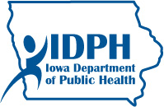

Allamakee County Assessment Workbook

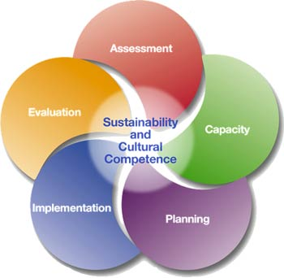

Iowa Partnerships for Success

December 2015

Table of Contents

Products and Datelines 6
Outcome-Based Prevention 8
Workbook Organization 10
Data Collection 10
Existing Data 10
Original Data 10
County Needs Assessment Workbook Contributors 12
Local Data Sources 14
Allamakee County Description 15
Description of Your County 15
Other Data Sources 17
Geography 17
Major highways 17
Adjacent counties 17
History 18
Communities 21
Townships 21
Unincorporated communities 21
Ghost towns 21
Consequence Data 24
Alcohol-Related Crimes 24
Alcohol-Related Car Crashes 25
Alcohol Dependence and Abuse 26
Alcohol School Suspensions and Expulsions 27
Other Data Sources 30
Final Consequences Question 30
Consumption Data 30
Underage Drinking Information 30
Other Data Sources 31
Final Consumption Question 32
Intervening Variables 32
Alcohol Availability (Retail) 32
Liquor Licenses and Per Capita Gallon Sales 32
Compliance Check Failure Rate 33
Percentage of Drive-Up Liquor Windows 33
Local Ordinances 34
Other Data Sources 36
Retail Availability Questions 36
Key Law Enforcement Interviews 36
Officers Assigned to Alcohol-Related Issues 37
Other Data Sources 37
Social Availability of Alcohol 37
County Level Data Sources 38
County Meetings or Focus Groups 38
Other Data Sources 38
Social Availability Questions 38
Promotion 39
Sponsorships 39
Advertising 40
Step One 40
Step Two 41
Other Data Sources 43
Promotional Questions 43
County Norms 44
County Meetings 46
Other Data 46
County Norms Questions 46
Surveys 47
Graduation Rates 48
Other Data Sources 49
Individual Factor Questions 49
County Priorities 50
Resource Assessment 51
Resources 51
Appendices 53
Appendix A. Law Enforcement Interviews 53
Notes for Law Enforcement Interview About Alcohol Use 57
Appendix B. County Meeting or Focus Groups Protocol 58
Notes for Town Hall Meeting About Alcohol Use 62
State Data Sources 64
Definitions 66
List of Abbreviations 66

List of Tables

Table 1: Deadlines for Activities and Workbook Completion 6
Table 2: Other Data Sources (See examples) 14
Table 3: County Facts, Source SDC and ACS, 2013 Population Estimate 15
Table 4: Youth Alcohol Related Arrests (rates per 10,000), Source JDW, CJJP 24
Table 5: Alcohol Related Fatal Crashes, Injuries and Drunk Drivers, Source GTSB 25
Table 6: Treatment Episodes (Number and Rate per 10,000 Population) for Alcohol Treatment in Iowa by County of Residence, source I-SMART 27
Table 7: Alcohol Related School Suspensions and Expulsions, Source Iowa Department of Education 27
Table 8: Proportion of Students Who Reported 30-Day and Binge Drinking, Source IYS 30
Table 9: Liquor License Rates and Per Capita Gallon Sales, Source ABD 32
Table 10: Proportion of Liquor License Holders That Failed a Compliance Check, Source evaluation subcommittee 33
Table 11: Drive-Up Liquor Windows and Liquor Licenses in Your County, source Iowa ABD 33
Table 12: Local Ordinances Targeting Alcohol in Your County, Source Evaluation subcommittee 34
Table 13: Proportion of Students Who Responded (Hard and Very Hard) to Perception of Neighborhood Alcohol Availability Question, Source IYS 38
Table 14: County Events and Their Alcohol-Related Sponsors Within Last Year, Source Evaluation subcommittee 39
Table 15: Local Alcohol Advertisements and Promotional Events, Source evaluation subcommittee 41
Table 16: Proportion of Students Who Responded (Agree and Strongly Agree) to Perception of Social Norms Questions, Source IYS 44
Table 17: Proportion of Students Who Responded (Wrong and Very wrong) on the Perception of Peer's Norms Questions, Source IYS 45
Table 18: Proportion of Student Who Responded (Wrong and Very Wrong) to Perception of Parental and Adult Neighbors Norms, Source IYS 45
Table 19: Risk and Protective Factors That Best Predict 30-Day Alcohol Use and Percentage of Students at Risk or Protected by Grade Levels, Source IYS, 2014 47
Table 20: Graduation Rates, Source Iowa Department of Education 49
Table 21: Current Resources and Strategies Focusing Upon the Underage and Binge Drinking by Intervening variables 52
Table 22: State Data Sources Used in the Assessment 64

List of Figures

Figure 1: Five Steps of the Strategic Prevention Framework Process 7
Figure 2: Outcome-Based Prevention (Lowther & Birchmayer, 2006) 8
Figure 3: Outcome-Based Prevention Logic Model 9

Introduction

SAMHSA’s Partnerships for Success funding builds upon the experience and established Strategic Prevention Framework (SPF) based prevention infrastructures of states/tribes to address two of the nation’s top substance abuse prevention priorities in communities of high need. The program is based on the premise that changes at the community level will, over time, lead to measurable changes at the state/tribal level.

Through Iowa Partnerships for Success (IPFS), the Iowa Department of Public Health, Division of Behavioral Health is funding highest need counties to address Iowa’s substance abuse prevention priorities of reducing underage and youth binge drinking among persons aged 12 to 20.

The SPF represents a five-step, data driven process used to 1) assess needs; 2) build capacity; 3) engage in a strategic planning process; 4) implement a strategic plan and 5) evaluate processes and outcomes. Cultural competency and sustainability are a focus across all five SPF steps.

Figure 1: Five Steps of the Strategic Prevention Framework Process

The first phase of the SPF model is Assessment, which involves the gathering and examination of data related to substance use and related consequences, community climate, environment, and infrastructure/resources. By design, this Community Needs Assessment Workbook is intended to walk you through the assessment process in a step-by-step manner to assess your local prevention needs.

Outcome-Based Prevention

The foundation of the SPF model is Outcomes-Based Prevention (Figure 2). This process details the planning steps that must occur for community-level change. The visual representation of this is also known as a logic model. Building the logic model begins with careful identification or mapping of the local substance use problem (and associated patterns of substance use and consequences among the population affected) and the factors or intervening variables that contribute to them.

Figure 2: Outcome-Based Prevention (Lowther & Birchmayer, 2006)
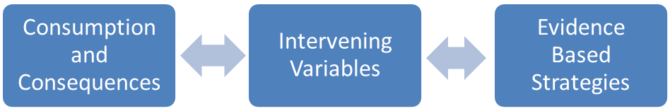

Consumption refers to the way people drink/consume alcohol. For example the number of underage youth in a community who have had a drink of alcohol in the last 30 days.

Consequences are the social, economic, and health problems associated with the use of alcohol. For example the number of youth who are suspended from school for alcohol violations or who receive a citation for driving under the influence.
.
Intervening Variables are the underlying factors that contribute to the problem. For example social or retail to access to alcohol for youth may contribute to the problem of underage drinking in a community.

Evidence Based Strategies have documented evidence of effectiveness and preferably have been rigorously tested and shown to have positive outcomes in multiple peer-reviewed evaluation studies.

All funded applicants will work towards the same outcomes/goals of the IPFS Project including:

- Reduce the rate of underage alcohol use rate of 8th and 11th grade drinkers by at least 5% in funded counties as measured by the Iowa Youth Survey (based on 2012-2014 and 2016-2018 Iowa Youth Survey results);

- Reduce the binge drinking rate of 8th and 11th grade drinkers by at least 5% in funded counties as measured by the Iowa Youth Survey (based on 2012-2014 and 2016-2018 Iowa Youth Survey results); and

- Implement at least one individual and four environmental evidence-based practices in the county.

The tasks that follow are based on the outcome-based prevention model and recent research detailing the intervening variables of substance-related problems. There are four major sections (problems, causes, prioritization, and resource assessment). Within each there are data to collect and questions to answer. Following from Iowa’s targeted need (underage and binge drinking) and the known Intervening Variables, the previous model can be expanded to include evidence- based strategies, as illustrated in Figure 3 (Birckmayer, Holder, Yacoubian, & Friend, 2004)¹

Figure 3: Outcome-Based Prevention Logic Model

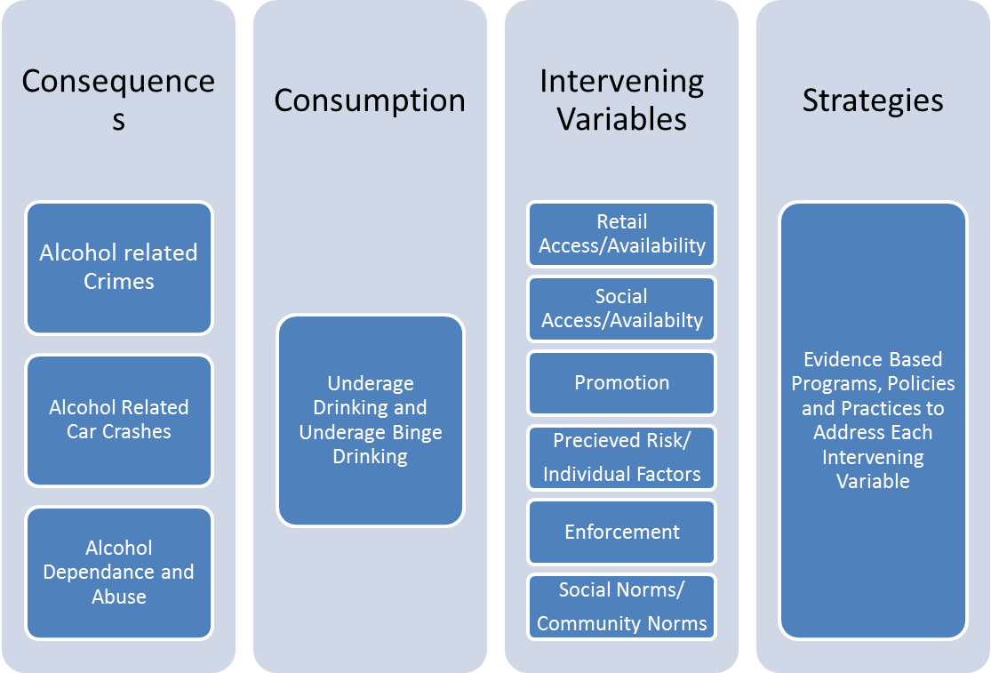

Workbook Organization

The workbook is organized into sections to assist you in working through the process of assessing the need, specifically by:

- Identifying consumption and consequence patterns with existing and original data
- Identifying the intervening variables that are contributing to the problem
- Setting priorities
- Identifying existing community resources
- Determining which intervening variables you will address

Data Collection
To be effective, you should not complete this workbook alone. Instead, an evaluation subcommittee of the coalition or Collaboration Council should be formed to complete this task. An evaluation subcommittee must include networks of people and organizations that bring substance abuse and mental health data, analytical thinking, and epidemiological capacity to prevention planning and decision-making in your county.³ You will also want to periodically convene your larger coalition or Collaborative Council to assist in identifying possible sources of data, solicit volunteers for data collection and interpretation, and to assist in setting priorities and deciding which intervening variables your county will focus on.

Much of the data needed in this workbook may be publicly available or provided to you. In other areas, where local level data is not available to IDPH, you will be responsible for finding the information. Proportions or rates are used for simplicity, and it is acknowledged that they may vary according to their margin of error. In addition to the existing data sources that are specifically outlined in this workbook, local surveys or other data sources are encouraged to be used as sources of auxiliary information to aid in the decision making process. Your county may have already gathered survey results from businesses or from local law enforcement that may help in the needs assessment.

Existing Data
You may be surprised at how much data already exists at your local or county level. Some of these data will be provided directly to you by IDPH. Other sources of data may come from your local law enforcement agencies, school district or city and county public health departments. Some examples include data gathered by local public health agencies as part of their Community Health Needs Assessment and Health Improvement Planning or information from school districts regarding graduation rates or the number of alcohol-related suspensions. A key to successful assessment is to identify who is already collecting local data and work collaboratively to access, analyze, and interpret such data.

Original Data
In several areas of this workbook you will be asked to gather original (new) information. The purpose of this data collection is to gather information directly from your county by observation or research. This will enable you to fill in gaps where existing data may not exist, or be incomplete. Examples of this will include interviews with key partners and stakeholders, including law enforcement, and conducting county focus groups and town hall meetings. More specific resources and templates for collecting this information can be found in Appendix A and B.

THIS PAGE WAS INTENTIONALLY LEFT BLANK

Allamakee County Assessment Workbook

Iowa Partnerships for Success

November 2015

County Needs Assessment Workbook Contributors

List the names of people in your county, the organizations they represent, and the contributions they made to complete this workbook in Table 2 below.

Table 2: Workbook Contributors

Name | Organization | Contribution
Toby V. Yak, MPH, PhD(c) | Iowa Department of Public Health | Data collection and analysis of state and county indicators
Maxine Grotegut | Allamakee IPFS Coordinator | Data collection and analysis of county indicators
Jean Bossom | Allamakee Substance Abuse Prevention Director | Data collection and analysis of county indicators
James R. Veale, Ph. D. | Allamakee IPFS Evaluator | Data collection and analysis of county indicators
Julie Rotach | ASAP Coalition Member | Analysis of county indicators
Clark Mellick | Allamakee County Sheriff | County-wide alcohol related data
Mike Halse | Postville Police Chief | Postville alcohol related data
Phil Young | Waukon Police Chief | Waukon alcohol related data
Allamakee County Clerk’s Office | District Court Office/Magistrate Court Office | Allamakee County alcohol related data
Allamakee County Sheriff’s Dispatchers | Allamakee County Sheriff’s Office | Allamakee County alcohol related data
Julie Rotach | ASAP Coalition Member | Allamakee County alcohol related data
City Clerk, City of Lansing | Lansing City Clerk | Lansing Ordinances
City Clerk, City of Harpers Ferry | Harpers Ferry City Clerk | Harpers Ferry Ordinances

Local Data Sources

In Table 3 below, list all the local (county/community) data sources used in this workbook as well as a description of the data, and where it came from.

Table 1: Other Data Sources (See examples)

Data Source | Data Description | Data Location
Iowa Youth Survey(state) | Statewide school survey of 6th, 8th, and 11th graders (2002, 2005, 2008, 2010, 2012, and 2014). Consumption variables | http://www.iowayouthsurvey.iowa.gov/
Justice Data Warehouse | The Justice Data Warehouse (JDW) is a central repository of key criminal and juvenile justice information from the Iowa Court Information System (ICIS) and information from the Iowa Correctional Offender Network (ICON) system. | http://www.humanrights.iowa.gov/cjjp/jdw/index.html
I-SMART | A web-based computing environment to enable IDPH and providers to share substance abuse treatment data. | http://wwwdasis.samhsa.gov/webt/tedsweb/tab_year.choose_year_web_table?t_state=IA
Iowa Data Center | State data center | Source SDC and ACS, 2013 Population Estimate
City-data.com | Profiles of cities in the United States. From crime rates to weather patterns. | http://www.city-data.com/county/Allamakee_County-IA.html#ixzz2apLWMLEu
Effigy Mounds | Answers.com is an Internet-based knowledge exchange | www.answers.com/topic/effigy-mound
Wikipedia | A free encyclopedia built collaboratively using wiki software. | http://en.wikipedia.org/wiki/Allamakee_County_Iowa
Iowa Department of Education | Education. State Organizations; Services; Related Links. Area Education Agencies · Department of Education | Iowa Department of Education
Iowa DNR | The Official Home page for the Iowa Department of Natural Resources, DNR. | www.iowadnr.gov
Governor’s Traffic Safety Bureau | The Iowa Governor's Traffic Safety Bureau is a subdivision of the Iowa Department of Public Safety | GTSB
Allamakee Community School District | Allamakee Community School District (Waukon) website | www.allamakee.k12.ia.us
Eastern Allamakee Community School District | Eastern Allamakee Community School District (Lansing) website | www.e-allamakee.k12.ia.us
Postville Community School District | Postville Community School District website | www.postville.k12.ia.us
Alcohol Beverage Division | Regulates all entities that sell alcohol and tobacco in the state | iowaabd.com
City of Waukon | Complete and current City of Waukon ordinances. | www.cityofwaukon.com
City of Postville | Complete and current City of Postville ordinances | http://www.cityofpostville.com/cgi-bin/csvsearch.pl?mytp=tpMenu1&mydb=db1&order_by=OrderOf&order=123&Page=Postville_Ordinances

Allamakee County Description

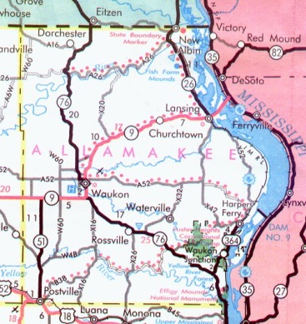

Description of Your County

Table 2: County Facts, Source SDC and ACS, 2013 Population Estimate

Allamakee County Demographics | Description | Allamakee County (N) | Allamakee County Rate (%) | Iowa (N) | Iowa Rate (%)
2013 Population Estimate | Total Population Estimate | 14,169 | N/A | 3,090,416 | N/A
Population by Gender | Male | 6,925 | 49% | 1,533,401 | 49%
Population by Gender | Female | 7,244 | 51% | 1,557,015 | 50%
Population by Age | <5 | 859 | 6% | 194,726 | 6%
Population by Age | 5 to 14 | 1,763 | 12% | 407,375 | 13%
Population by Age | 15 to 24 | 1,592 | 11% | 439,247 | 14%
Population by Age | 25 to 34 | 1,462 | 10% | 390,593 | 13%
Population by Age | 35 to 44 | 1,423 | 10% | 361,649 | 12%
Population by Age | 45 to 54 | 1,991 | 14% | 414,402 | 13%
Population by Age | 55 to 64 | 2,160 | 15% | 401,545 | 13%
Population by Age | 65 to 74 | 1,540 | 11% | 250,275 | 8%
Population by Age | 75 to 84 | 940 | 6% | 152,109 | 5%
Population by Age | 85 and over | 439 | 3% | 78,495 | 3%
Race/Ethnicity | White | 13,619 | 96% | 2,857,316 | 92%
Race/Ethnicity | Black or African American | 209 | 1% | 101,368 | 3%
Race/Ethnicity | American Indian and Alaska Native | 87 | 0% | 14,742 | 0%
Race/Ethnicity | Asian Alone | 69 | 0% | 63,291 | 2%
Race/Ethnicity | Hispanic or Latino Origin | 821 | 6%
Race/Ethnicity | Native Hawaiian and Other Pacific Islander | 39 | 0% | 2753 | 0%
Race/Ethnicity | Other Race | 146 | 1% | 50,946 | 2%
Income (2009-2013) | Median Household Income | $44,673 |  | $52,286
Educational Attainment (2009-2013) | No Schooling Completed | 36 | 0% | 13,765 | 0%
Educational Attainment (2009-2013) | High School Graduate, GED, or Alternative | 4,383 | 31% | 666,371 | 22%
Educational Attainment (2009-2013) | Some College or Associate’s Degree | 1,334 | 9% | 286,373 | 9%
Educational Attainment (2009-2013) | Bachelor’s Degree | 1,101 | 8% | 359,520 | 12.1%
Economic Characteristics (2009-2013) | Below Poverty for All Ages | 1,930 | 13.9% | 377,037 | 12.6%
 | Under 18 years | 662 | 5% | 114,304 | 4%
 | 18 to 64 years | 849 | 44% | 248,844 | 66%
Government Assistance (2013) | Food Assistance Benefits (Average Monthly Households) | 744 | 5% | 198,572 | 6%
Government Assistance (2013) | Food Assistance Benefits (Total Annual Benefits) | $2,202,521 |  | $578,994,624
Government Assistance (2013) | Medicaid Benefits (Average Monthly Recipients Eligible) | 2147 | 15% | 512,983 | 16%
Government Assistance (2013) | Medicaid Benefits (Total Annual Benefits) | $17,114,014 |  | $3,588,516,427
NOTE: Percent Rate = (N ÷ Total Population Estimate) × 100%

Other Data Sources

In Allamakee County you will find the beauty of nature, the intrigue of history and the peace of a vacation paradise nestled in the rolling hills and striking bluffs of Northeastern Iowa. The wonders of nature are waiting around every turn as you explore our numerous preserved areas, parks and historical sites, including the internationally known Effigy Mounds National Monument - Iowa's only National Park. There is an abundance of recreational opportunities & outdoor expeditions waiting for you year-round in Allamakee County, making every moment here anything but ordinary! ~ Allamakee County Economic Development and Tourism brochure.

Allamakee County (pronounced AL-uh-muh-KEY) is the northeastern-most county located in the U.S. State of Iowa. The population was 14,330 in the 2010 census, a decline from 14,675 in 2000.[1][2] Its county seat is Waukon.
Area  - Total  - Land  - Water | Allamakee County, Iowa  658.71 sq. mi (1,706 km²)  639.56 sq. mi (1,656 km²)  19.14 sq. mi (50 km²), 2.91%

Geography

According to the 2000 census, the county has a total area of 658.71 square miles (1,706.1 km²), of which 639.56 square miles (1,656.5 km²) (or 97.09%) is land and 19.14 square miles (49.6 km²) (or 2.91%) is water.

Major highways

- U.S. Highway 18  - U.S. Highway 52  - Iowa Highway 9 | - Iowa Highway 26  - Iowa Highway 51  - Iowa Highway 76

Adjacent counties

- Houston County, Minnesota (north)
- Vernon County, Wisconsin (northeast)
- Crawford County, Wisconsin (east)
- Clayton County (south)
- Winneshiek County (west)
- Fayette County (southwest)

History

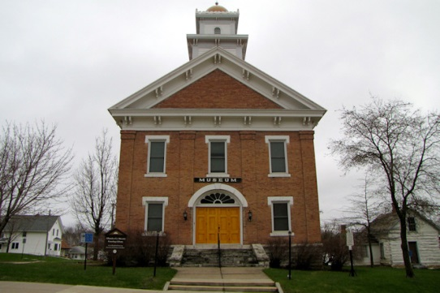
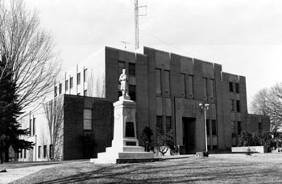
Allamakee County was formed on February 20, 1847 from free territory. The first Allamakee County Courthouse, built in 1861, now serves as the Allamakee County Historical Museum. The present Allamakee County Court House was built in 1940. Both courthouse buildings are listed on the National Register of Historic Places.

Demographics

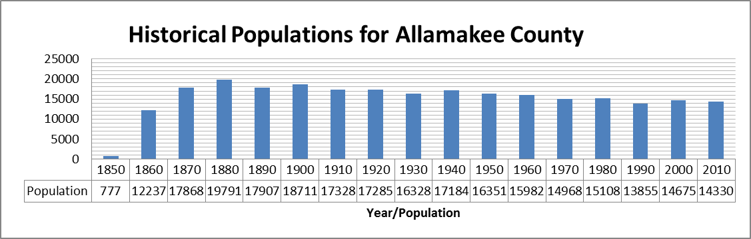

2010 census

The 2010 census recorded a population of 14,330 in the county, with a population density of 22.39/sq. mi (8.65/km²). There were 7,617 housing units, of which 5,845 were occupied.

2000 census

As of the census^{[6]} of 2000, there were 14,675 people, 5,722 households, and 3,931 families residing in the county. The population density was 23 people per square mile (9/km²). There were 7,142 housing units at an average density of 11 per square mile (4/km²). The racial makeup of the county was 95.88% White, 0.14% Black or African American, 0.18% Native American, 0.27% Asian, 0.01% Pacific Islander, 2.82% from other races, and 0.70% from two or more races. 3.54% of the population were Hispanic or Latino of any race.
There were 5,722 households out of which 30.60% had children under the age of 18 living with them, 58.40% were married couples living together, 6.60% had a female householder with no husband present, and 31.30% were non-families. 27.50% of all households were made up of individuals and 14.30% had someone living alone who was 65 years of age or older. The average household size was 2.49 and the average family size was 3.02.

In the county the population was spread out with 25.40% under the age of 18, 7.00% from 18 to 24, 25.60% from 25 to 44, 23.60% from 45 to 64, and 18.40% who were 65 years of age or older. The median age was 40 years. For every 100 females there were 100.20 males. For every 100 females age 18 and over, there were 98.90 males.
The median income for a household in the county was $33,967, and the median income for a family was $40,589. Males had a median income of $26,122 versus $19,098 for females. The per capita income for the county was $16,599. About 6.40% of families and 9.60% of the population were below the poverty line, including 11.80% of those under age 18 and 8.10% of those age 65 or over.

Most common first ancestries reported in Allamakee County (%)

- German (41%)
- Norwegian (17%)
- Irish (16%)
- United States or American (6%)
- English (4%)
- Ukrainian (1%)
- French (except Basque) (1%)

Agriculture in Allamakee County

Average size of farms: 301 acres
Average value of agricultural products sold per farm: $84,049
Average value of crops sold per acre for harvested cropland: $197.13
The value of livestock, poultry, and their products as a percentage of the total market value of agricultural products sold: 68.68%
Average total farm production expenses per farm: $73,547
Harvested cropland as a percentage of land in farms: 44.34%
Average market value of all machinery and equipment per farm: $106,884
The percentage of farms operated by a family or individual: 89.29%
Average age of principal farm operators: 55 years
Average number of cattle and calves per 100 acres of all land in farms: 21.13
Milk cows as a percentage of all cattle and calves: 17.75%
Corn for grain: 61997 harvested acres
Soybeans for beans: 28935 harvested acres
Vegetables: 42 harvested acres
Land in orchards: 77 acres

Most common occupations (%)

Males
- Farmers and farm managers (15%)
- Other production occupations including supervisors (7%)
- Agricultural workers including supervisors (6%)
- Driver/sales workers and truck drivers (6%)
- Other sales and related workers including supervisors (5%)
- Metal workers and plastic workers (5%)
- Food processing workers (4%)
Females
- Other production occupations including supervisors (6%)
- Secretaries and administrative assistants (6%)
- Nursing, psychiatric, and home health aides (6%)
- Preschool, kindergarten, elementary and middle school teachers (5%)
- Cooks and food preparation workers (4%)
- Other office and administrative support workers including supervisors (4%)
- Other management occupations except farmers and farm managers (4%)
http://www.city-data.com/county/Allamakee_County-IA.html#ixzz2apLWMLEu

Household type by relationship

Households: 13,998
- In family households: 11,631 (3,155 male householders, 730 female householders)
3,227 spouses, 3,892 children (3,691 natural, 74 adopted, 127 stepchildren), 140 grandchildren, 68 brothers or sisters, 61 parents, 74 other relatives, 253 non-relatives

- In nonfamily households: 2,367 (1,023 male householders (821 living alone)), 937 female householders (832 living alone)), 407 nonrelatives

- In group quarters: 332 (318 institutionalized population)

Size of family households: 2,052 2-persons, 718 3-persons, 588 4-persons, 304 5-persons, 148 6-persons, 75 7-or-more-persons.

Size of nonfamily households: 1,653 1-person, 246 2-persons, 39 3-persons, 15 4-persons, 3 5-persons, 1 6-persons, 3 7-or-more-persons.

91.8% of residents of Allamakee County speak English at home.

3.8% of residents speak Spanish at home (12% speak English very well, 24% speak English well, 10% speak English not well, 54% don't speak English at all).

4.0% of residents speak other Indo-European language at home (58% speak English very well, 18% speak English well, 19% speak English not well, 6% don't speak English at all)
.
0.1% of residents speak Asian or Pacific Island language at home (26% speak English very well, 63% speak English not well, 11% don't speak English at all).

0.2% of residents speak other language at home (54% speak English very well, 19% speak English well, 27% speak English not well).
http://www.city-data.com/county/Allamakee_County-IA.html#ixzz2apNFb0Jw

Hydrology and geology

In the northern part of the county is the Upper Iowa River. In the southern part is the Yellow River. The eastern boundary is the Mississippi River. All offer scenic and recreational opportunities, particularly in Yellow River State Forest.
French Creek flows north of Waukon, outside the city limits. Paint Creek, named after Paint Rock Bluff, flows out of the south of Waukon. Norfolk creek originates in the western outskirts of Waukon and is effluent to the Yellow River. Clear Creek flows into Lansing. Village Creek flows through essentially rural terrain. All are tributary to the Mississippi River.
The landforms encountered in the county are very unlike those found in most of Iowa, which is on the whole is absent Glacial Drift. As part of the Driftless Area, the county was ice free during the last ice age, and as one progresses to the Mississippi River, the streams and rivers display high-walled canyons carved of Silurian period bedrock. This Driftless Area also includes parts of Clayton, Fayette, Winneshiek, Howard, Dubuque, and Jackson Counties.

Communities

- Harpers Ferry  - Lansing | - New Albin  - Postville (part) | - Waterville  - Waukon

Townships

Allamakee County is divided into eighteen townships:
- Center  - Fairview  - Franklin  - French Creek  - Hanover | - Iowa  - Jefferson  - Lafayette  - Lansing  - Linton | - Ludlow  - Makee  - Paint Creek  - Post  - Taylor | - Union City  - Union Prairie  - Waterloo

Unincorporated communities

- Dorchester  - Ludlow | - Lycurgus  - Rossville | - Church  - Volney

Ghost towns

- Hardin | - Columbus  - Ion | - Village Creek  - Myron
*http://en.wikipedia.org/wiki/Allamakee_County_Iowa

Notable sites

- Effigy Mounds National Monument is found in the southeast corner of the county.
- Upper Mississippi River National Wildlife and Fish Refuge encompasses the River.
- Driftless Area National Wildlife Refuge, a collection of small, non-contiguous parcels harboring two endangered species.
- Yellow River State Forest is a four-season state park.

Effigy Mounds, Allamakee County (Iowa’s only National Park)

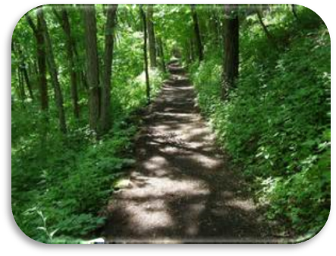
Archaeological site, northeastern Iowa, U.S. Located on the Mississippi River, it covers 4 sq. mi (10 sq. km). Established in 1949, the monument has 183 known mounds, some of which are in the shape of birds and bears. The mounds were built over the course of the Woodland period (1000 1200), with the effigy mounds probably constructed between 400 and 1200. Many mounds have yielded copper, bone, and stone tools of Indian origin. One of the bear mounds is 137 ft. (42 m) long and 3.5 ft. (1 m) high. www.answers.com/topic/effigy-mounds
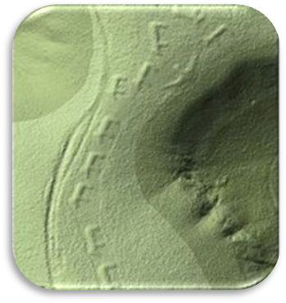
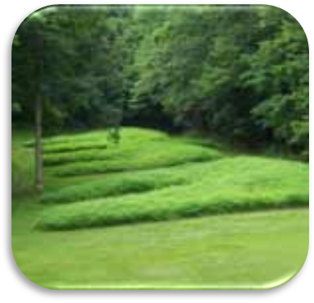

Yellow River Forest Reserve, Allamakee County

Yellow River Forest is located in Allamakee County in northeast Iowa. Its headquarters and recreation facilities are located on county highway B25, approximately 4 miles southeast of Waterville or 3 miles west of Harpers Ferry.

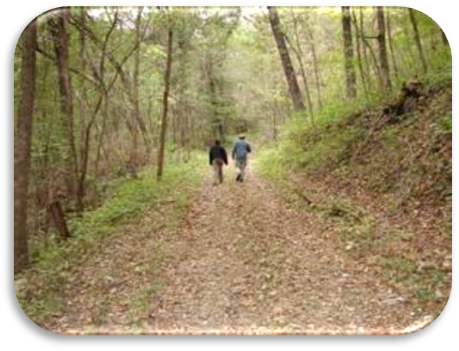
The Paint Creek Unit is of primary interest to the recreationist. It has the Big Paint Creek, Little Paint Creek and equestrian campgrounds with capacities of 48, 80 and 40 sites respectively. It also contains 6 miles of trout stream stocked from April through October and a marsh from which bass and panfish may be taken.

Hiking, snowmobile and horse trails and several picnic areas are located on the Paint Creek unit. Several scenic overlooks are accessible by horseback, foot or auto and a large portion of the cross country ski trail system is found here. www.iowadnr.gov

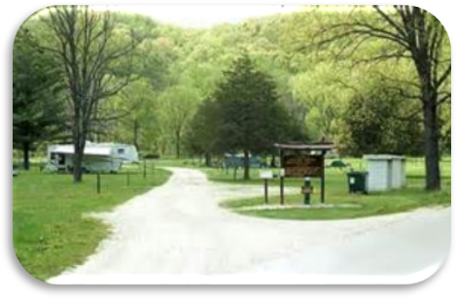
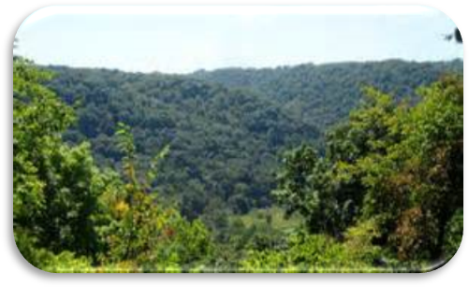

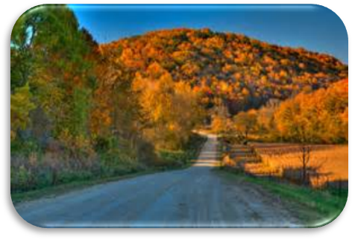
Beautiful (Rural) Allamakee County
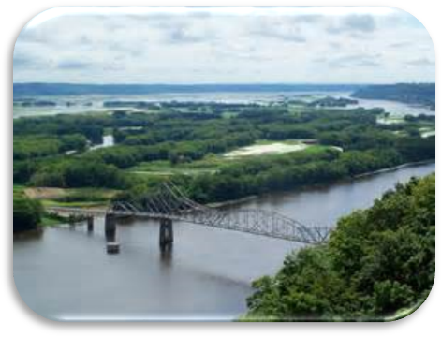

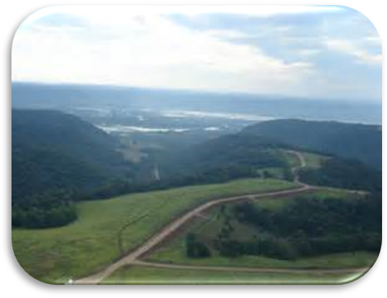
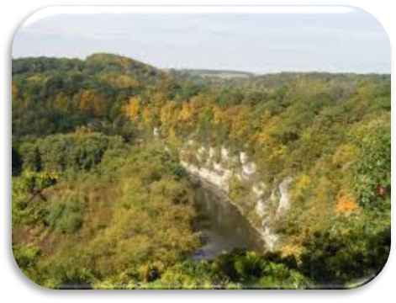

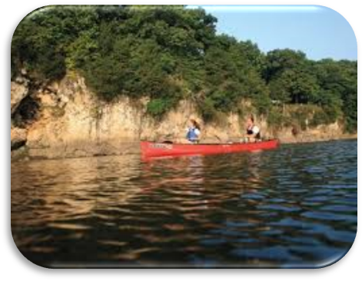
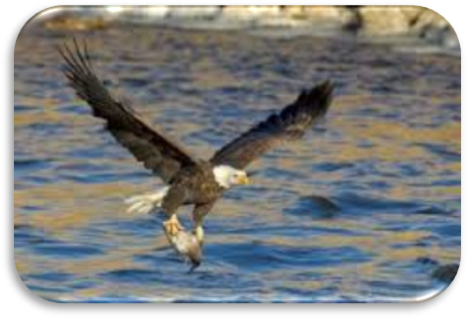

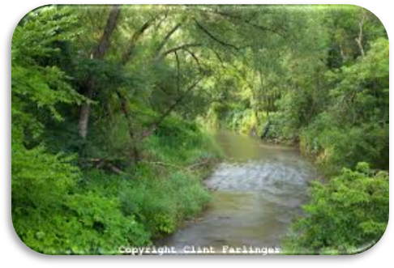
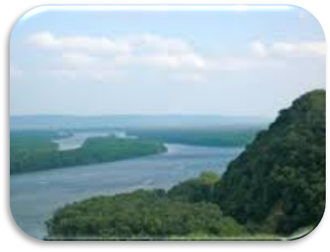
Question 1: Add any other information or unique historical, social and cultural particulars that you feel important to specifically describe your county.

Answer 2015: In the 1850’s, Allamakee County was settled by immigrants of German, Norwegian and Irish heritage. Many of the customs and traditions of these cultures endure today.
Allamakee County consists of a culture of hard-working, low-income, caring individuals who value agriculture, outdoor recreation, and exemplify a strong work ethic.
Most individuals are fortunate to have close-knit families and friends. Family and cultural traditions are important and have endured over time. They continue to impact current social gatherings.
Wedding celebrations, graduations and other social events are attended by many and celebrated with alcohol.
The variety of outdoor recreation allowed in the rural setting of Allamakee County, i.e. hunting, fishing, boating, horseback riding, canoeing, kayaking, tubing, camping, snowmobiling, and ATV four wheeling are oftentimes a part of weekend activities for many, including families with children. Although not all adults use alcohol while taking part in these activities, many adults do. For some no matter what the activity, alcohol is a part of the activity. Families who involve their children in these recreational activities, and who also use alcohol or are with others who use alcohol, expose their young children to the idea that alcohol is a necessary part of these activities.

Consequence Data

This section looks at alcohol-related consequence data and will help you identify which alcohol-related consequences are of greatest concern in your county.

Alcohol-Related Crimes

Table 3: Youth Alcohol Related Arrests (rates per 10,000), Source JDW, CJJP
Alcohol-Related Crimes Juveniles | Area | 2012  N Rate |  | 2013  N Rate
Alcohol Offenses | Allamakee County | 37 | 106.1 | 23 | 66.7
Alcohol Offenses | Iowa | 10,585 | 129.8 | 8,636 | 106
Operating While Intoxicated | Allamakee County | * | 2.9 | * | 14.5
Operating While Intoxicated | Iowa | 1,702 | 20.9 | 1,477 | 18.1
Note: IDPH will provide this data. JDW is continuously being updated; therefore no new queries will be offered after the data have been pulled.
* Number less than five/numbers are withheld to preserve anonymity.

Other Data Sources

This is an important part of the county assessment since it relates to your county specific data not available at the state level. Identify all other data that address problems around the consequences of alcohol related crimes. For example, you have knowledge of local surveys, of trouble spots or specific alcohol related strategies that the law enforcement agencies are implementing. You may have data not reported to the state on Minor in Possession arrests and/or citations. In this case describe the results here:

Question 2:
Based on the preceding tables and your other local level data, how do alcohol-related offenses and convictions in your county compare to the state? Is your problem bigger, smaller or about the same? Discuss the differences.

Answer 2015: The rates per 10,000 of alcohol offenses and operating vehicles while intoxicated for Allamakee County were below those of the state in both years cited. The county rate for alcohol offenses was reduced in 2013 over 2012, while the county rate for operating while intoxicated increased over this period. Since the state rate for operating while intoxicated decreased slightly from 2012 to 2013, the increase in the county rate indicates that this is an area for concern.
Allamakee County consists of many miles of gravel roads, and with the small law enforcement departments, people have learned to take gravel roads home from wherever they are drinking alcohol, in order to avoid law enforcement. On a weekend night, there may be two county deputies to patrol all the roads in Allamakee County. This may very well account for the small number of arrests.

Alcohol-Related Car Crashes

Another targeted consequence of underage drinking and binge drinking for the IPFS Project is car crashes related to alcohol use.

Table 4: Alcohol Related Fatal Crashes, Injuries and Drunk Drivers, Source GTSB
Indicators | Area | 2010 | 2011 | 2012
Fatal Crashes N (Rate) | Allamakee County N | 4 | 1 | 2
Fatal Crashes N (Rate) | Rate | 2.8 | 0.7 | 1.4
Fatal Crashes N (Rate) | Iowa N | 348 | 329 | 330
Fatal Crashes N (Rate) | Rate | 1.2 | 1.1 | 1.1
Drivers Involved in Fatal Crashes That Have Had a Drink (Rate) | Allamakee County N | 3 | 0 | 1
 | Rate | 2.1 | 0 | 0.7
 | Iowa N | 85 | 83 | 96
 | Rate | 0.3 | 0.3 | 0.3
Alcohol-Related Traffic Injuries  N (Rate) | Allamakee County N | 9 | 10 | 11
Alcohol-Related Traffic Injuries  N (Rate) | Rate | 6.3 | 7.0 | 7.7
Alcohol-Related Traffic Injuries  N (Rate) | Iowa N | 2,417 | 2,389 | 2,275
Alcohol-Related Traffic Injuries  N (Rate) | Rate | 7.8 | 7.7 | 7.4

Other Data Sources

Consider and analyze other data sources that will help identify and detail problems around the consequences of alcohol and motor vehicles. Describe results here:

Question 3
Based on preceding Tables and your community level data, how do alcohol-related car crashes in your county compare to alcohol-related car crashes across the state? Is your problem bigger, smaller or about the same? Discuss the differences.

Answer 2015: Regarding fatal crashes, the county and state rates are fairly similar and low. For drivers involved in fatal crashes who have had a drink, the county rate was higher than the state rate in 2010, but was similar to the state rate in 2011 and 2012. In terms of alcohol-related traffic injuries, the rate of county and state are fairly similar. However the county rates are increasing, while the state rates are decreasing.

Alcohol Dependence and Abuse

Table 6 below shows the rate by county of residence for treatment admissions due to alcohol as the primary or secondary drug. The Iowa rate has been included in the table to provide a comparison. The year-specific estimated census data were used for that purpose.

Table 5: Treatment Episodes (Number and Rate per 10,000 Population) for Alcohol Treatment in Iowa by County of Residence, source I-SMART
Area | 2012 | 2013
Allamakee County N  Rate | * | 6
Allamakee County N  Rate | 14.3 | 17.4
Iowa N  Rate | 394 | 1205
Iowa N  Rate | 4.8 | 14.8
Note: IDPH will provide this data.
* Number less than five/numbers are withheld to preserve anonymity.

Other Data Sources

Consider and analyze other data sources that will help identify and detail problems around the consequences of alcohol dependence and abuse. For example you may have information from local surveys or from treatment facilities in your communities. If so describe the results here:

Question 4
Based on your county data, how does alcohol dependence and abuse in your county compare to alcohol dependence and abuse across the state? Is your problem bigger, smaller or about the same? Discuss the differences.

Answer 2015: Based on data on treatment episodes, alcohol dependence and abuse in our county is higher than that in the state. Alcohol treatment episodes are increasing on both the state and county levels. However, the rate increased more in the state than in our county from 2012 to 2013, yielding fairly comparable rates for the county and state in the latter year.

Alcohol School Suspensions and Expulsions

The following table describes the rate of school alcohol-related suspensions and expulsions from the Iowa Department of Education data center. Identify your district and the total number of suspensions and expulsions because of alcohol for each year and calculate the rate using this formula: (total number of suspension-expulsion/total number of students in the district) X 10,000.

Table 6: Alcohol Related School Suspensions and Expulsions, Source Iowa Department of Education
Youth Alcohol Suspension and Expulsion Rate (per 10,000) | 2011-2012 | 2012-2013 | 2013-2014
District 1: Allamakee Community School District  District 2: Eastern Allamakee Community School District  District 3: Postville Community School District  N | 0  0  0 | 0  0  0 | 0  0  0
Rate | 0 | 0 | 0
Allamakee County N | 0 | 0 | 0
Rate | 0 | 0 | 0
Iowa N | 382 | 341 | 306
Rate | 7.5 | 6.7 | 6.0

Question 5
Based on your county data, how does alcohol related school suspensions and expulsions in your county compare to the state?
Is your problem bigger, smaller or about the same? Discuss the differences.

Answer 2015: According to the data in Table 7, Allamakee County school districts reported zero suspensions or expulsions in the last three years. The rate for the state ranged from 6.0 to 7.5 alcohol related suspensions/expulsions per 10,000 students.

List some of the districts policies regarding suspensions and expulsions of students

Allamakee Community School District (Waukon)
Disciplinary Action and Seriousness of Offense
Solid discipline based on mutual respect is critical to maintaining an appropriate learning environment. Decisions and disciplinary actions are based on what is right (accordingly to school policy) just and consistent. Students who fail to meet the conduct expectations of the school are subject to consequences commensurate with the seriousness of their violation. The following are examples of severe misbehaviors and may result in an immediate administrative referral and possible suspension from school:
1. Swearing or verbal abuse toward a student or an adult
2. Threatening, fighting, or physical assaults toward others
3. Verbal, physical, and/or cyber bullying, harassment, hazing
4. Insubordination (refusal, disobedience, defiance) and disrespect
5. Vandalism which includes the destruction of school property or another student’s property
The following disciplinary actions are guidelines for rule infractions starting at the least serious and elevating to the most serious.
• Verbal warning
• Detention
• In-School Suspension (ISS)
• Office In-School Suspension (OISS)
• Behavior Contract
• School Service
• Out-of-School Suspension (OSS) Student will not be admitted back into class after an OSS until a family meeting has been held with building principal.
• Expulsion: School Board must approve all expulsions and re-admittance after expulsion has been completed.
Disciplinary action will be determined and assigned by a building administrator depending on the severity of the incident. Many consequences are dictated by various school board policies. Due process rights are guaranteed to all students and guardians that object to assigned consequences. A request for a hearing may be filed with the next level in the school district’s chain of command – teacher, principal, superintendent, and board of education.

Eastern Allamakee Community School District (Lansing)
Disciplinary Action
Solid discipline based on mutual respect is critical to maintaining an appropriate learning environment. Students that fail to meet the conduct expectations of the school are subject to consequences commensurate with the seriousness of their violation. The potential consequences by rank of severity are as follows:
• verbal reprimand
• after-school detention
• in school suspension
• permanent removal from class
• out-of-school suspension
• expulsion from school
The principal is responsible for assigning any and all consequences that are more severe than simple after-school detentions. Many consequences are dictated by various school board policies outlined at the end of the handbook. Due process rights are guaranteed to all students and guardians that object to assigned consequences. A request for a hearing may be filed with the next level in the school district’s chain of command – teacher, principal, superintendent, board of education.

Postville Community School District
Disciplinary Measures (BP 503.1)
Administrative Conference
Reprimand
Probation means a student is given a conditional suspension of a penalty for a definite period of time in addition to being reprimanded. The conditional suspension shall mean the student must meet the conditions and terms for the suspension of the penalty. Failure of the student to meet these conditions and terms shall result in the immediate reinstatement of the penalty.
Detention means the student’s presence is required during non-school hours for disciplinary purposes. The student can be required to appear prior to the beginning of the school day or after school has been dismissed for the day. Whether a student will serve detention, and the length of the detention, shall be within the discretion of the licensed employee disciplining the student or the building principal. Detentions will start to be served within twenty-four hours after the student has met with the principal after the due process hearing.
Removal from class means a student is sent to the building principal’s office. It shall be within the discretion of the person in charge of the classroom to remove the student. Students removed from class may be readmitted, placed on independent study outside the classroom, or withdrawn failing from the class at the discretion of the classroom teacher in consultation with the guidance counselor and administration.
Suspension (BP 503.1R1)
In-school suspension or an out-of-school suspension, a restriction from activities or loss of eligibility. An in-school suspension means the student will attend school but will be temporarily isolated from one of more classes while under suspension. An in-school suspension will not exceed ten consecutive school days. An out-of-school suspension means the student is removed from the school environment, which includes school classes and activities. An out-of-school suspension will not exceed ten days. A restriction from school activities means a student will attend school and classes and practice but will not participate in school activities or games.
Intervention Center may be an alternative to in-school or out-of-school suspension.
Shadowing by Parent is an alternative to in-school suspension. An in-school suspended student may have a parent shadow them through their schedule including lunch to assure proper conduct rather than serving the suspension.

Other Data Sources

Consider and analyze other data sources that will help identify and detail problems around the consequences of alcohol. For example, you may have information from local surveys, or you may know about certain trouble spots for Alcohol related crashes, areas where there are other considerations regarding dependence such treatment centers, schools and even the law enforcement and justice department in your county. If you have other data sources describe the results here:

Final Consequences Question

Question 6
Based on your data and responses to previous consequence questions, what are your county’s major concerns surrounding underage and binge drinking? Please provide supporting evidence here and reference the section and page where the information may be found.

Answer 2015: It is unclear how to determine consequence data regarding consequences for students due to the fact students are rarely suspended/expelled for alcohol-related violations. All school districts in Allamakee County have Good Conduct policies regarding participation in extra-curricular activities, but there is no information on how many Good Conduct policy violations for alcohol exist or consequences for students who are not involved in school activities.

Allamakee County recognizes that underage drinking remains an area of concern. As the data from Table 5 indicates, rates for alcohol-related traffic injuries has increased for Allamakee County from 6.3 in 2010, 7.0 in 2011 and 7.7 in 2012 while the rates for alcohol-related traffic injuries have declined from 7.8 in 2010, 7.7 in 2011 and 7.4 in 2012 for the State of Iowa.

Consumption Data

This section looks at alcohol consumption data and will help you identify any consumption concerns in your county. Consumption data includes information about the percentage of underage people who drink alcohol and the percentage of youth who engage in binge drinking (males having five or more and females having four or more drinks on one occasion).

Underage Drinking Information

Table 7: Proportion of Students Who Reported 30-Day and Binge Drinking, Source IYS

Indicators | Area | Grade | 2010 | 2012 | 2014
Indicators | Area | Grade | % | % | %
Students Who Have Had a Drink in the past 30 Days - (%)- Questions: 2010-B30; 2012-B18; 2014-B16 | Allamakee County | All | 28% | 18% | 16%
 | Allamakee County | 11th | 53% | 44% | 39%
 | Iowa | All | 17% | 11% | 10%
 | Iowa | 11th | 32% | 26% | 23%
Students Who Report Binge Drinking in the past 30 Days - (%)- Questions: 2010-B26; 2012-B16; 2014-B17 | Allamakee County | All | 20% | 14% | 11%
 | Allamakee County | 11th | 41% | 37% | 28%
 | Iowa | All | 11% | 8% | 6%
 | Iowa | 11th | 24% | 19% | 14%

Other Data Sources

Consider analyzing other data sources that will help identify and detail problems around underage drinking. A few examples include, your county may have its own specific alcohol survey involving underage drinking, or may want to consider college data, or data from alternative schools if there is one in your county. If you have access to other data, describe the results here:

Question 7
Based on Table 8, and your county’s own local data, how does student 30-day use of alcohol and binge drinking in your county compare to student data across the state? Discuss the differences and the trends in your county.

Answer 2015: Positive trends in both 30-day use of alcohol and binge drinking were observed in our county, both among 11th graders and overall. These trends are similar to those of students in the state, but the percentages in our county remain substantially higher than those of students in the state. For example, 11th grade students in Allamakee County who have had a drink in the past 30 days were 16% higher than the state rate in 2014. Students who reported binge drinking in the past 30 days is double that of the state, with Allamakee County 11th graders reporting binge drinking at a rate of 28% while 14% of the state 11th graders reported the same.

Other Data Sources

Consider and analyze other data sources that will help identify and detail problems around underage drinking and youth binge drinking. A few examples include, your county may have its own specific alcohol survey involving underage drinking, or your county may want to consider college data, or data from alternative schools if there is one in your county. If you have other data sources describe the results here:

Question 8
Based on previous table, along with your county’s other data sources, how does underage drinking, and youth binge drinking in your county compare to underage drinking, and youth binge drinking across the state?

Answer 2015: According to the previous table, Allamakee County has a higher usage rate of alcohol compared to state level. Binge drinking rates are higher as well. However, these rates are declining. As stated in the previous question Allamakee County’s 11th grade rates of students binge drinking are double that of the state rate. However, this is a decline from 41% in 2010 to 28% in 2014. The state rate of binge drinking is also declining. The state rate of 11th graders binge drinking in 2010 was 24% but in 2014 was 14%

Final Consumption Question

Question 9
Based on the consumption data analyzed here and on your answers to the previous questions, what are your county’s major concerns surrounding the problem of underage drinking and youth drinking? Justify your decision.

Answer 2015: One of the concerns and challenges of Allamakee County is that some parents find it acceptable to serve alcohol to minors. Their perception is that it is better to drink at home than drink and drive.
Community norms regarding alcohol use seem to support the acceptance of alcohol in a variety of social settings. Drinking is central to many recreational activities, celebrations and ways to celebrate contribute to underage drinking and underage binge drinking.

Intervening Variables

Alcohol Availability (Retail)

Liquor Licenses and Per Capita Gallon Sales

The most fundamental way to understand availability around alcohol use is through the number of opportunities people have to buy alcohol. Consider the following table, which compares the number of liquor license issued in your county and the state. This table includes all liquor license types.

Table 8: Liquor License Rates and Per Capita Gallon Sales, Source ABD
Per Capita- Indicators (per population over 18 Years Old) | Area | 2010 | 2012 | 2014
Liquor Licenses | Allamakee County | 61 | 65 | 67
Liquor Licenses | Rate | 55.4 | 63.44 | 65.39
Liquor Licenses | Iowa | 9,223 | 9,463 | 9,325
Liquor Licenses | Rate |  | 43.45 | 42.81
Gallon Sales | Allamakee County | 16,748 | 17,315 | 17,616
Gallon Sales | Rate | 1.52 | 1.69 | 1.72
Gallon Sales | Iowa | 4,399,102 | 4,859,878 | 5,019,617
Gallon Sales | Rate | 1.90 | 2.23 | 2.30
Note: IDPH will provide this data.

Compliance Check Failure Rate

The selling of alcohol to minors can contribute to underage drinking and binge drinking in your county. One measure of this is the failure of compliance checks by retail outlets. Consider the following table for input. Since this information is not available at the state level, you will need to generate it from your community law enforcement agencies. You will have to list the communities in the county. The timeframe for the compliance checks will be in the last two years.

Table 9: Proportion of Liquor License Holders That Failed a Compliance Check, Source evaluation subcommittee
Allamakee County | Number of Licenses | Number visited | Number that failed the check | Percent visited | Percent Failed
2012 | 62 | 14 | 0 | 23 | 0
2013 | 65 | 14 | 0 | 22 | 0
2014 | 72 | 14 | 1 | 19 | .07
Note: ABD does not conduct compliance checks for alcohol (CJJP & DOT, Iowa State Patrol)
Per Allamakee County Sheriff Department/SPF SIG Compliance Checks of Convenience/Grocery Stores

Question 10
Comment on the extent of alcohol retail compliance checks happening in your county. What are the barriers or challenges for county law enforcement agencies completing alcohol compliance checks?

Answer 2015: Law enforcement officers complete compliance checks twice a year in Allamakee County. They are willing to perform these checks, so the only real barrier is the financial cost to complete them.

Percentage of Drive-Up Liquor Windows

The percentage of drive-up liquor windows in your county can contribute to alcohol-related concerns because drive-up liquor windows make alcohol more easily obtainable and may encourage drinking and driving. This section will help you determine both the number of establishments with drive-up liquor windows and also what percentage of the liquor license holders in your county have them. You may have to search the Iowa ABD for establishments that hold liquor licenses in your county.

Table 10: Drive-Up Liquor Windows and Liquor Licenses in Your County, source Iowa ABD

Allamakee County | Name of establishment with drive-up liquor window
 | 0

Number of liquor licenses (from Table 10) = ____72____
County drive-up liquor window percentage =_____0 ___

Question 11
Comment on your county drive-up liquor percentage. How does it influence drinking and driving, loitering, safety? Please refer to your county OWI charges numbers and think whether there might be a relation.

Answer 2015: Allamakee County N/A

Local Ordinances

Local policies can dissuade drinking and loitering. In Table 13, list the local or countywide ordinances related to alcohol.

Table 11: Local Ordinances Targeting Alcohol in Your County, Source Evaluation subcommittee
Ordinance | Harpers Ferry | Lansing | Postville | Waukon
Persons Under Legal Age.  1. Social Host. A person who is the owner or lessee of, or who otherwise has control over, property that is not a license premises shall not knowingly permit any person. . . under the age of eighteen, to consume. .. alcoholic liquor, wine or beer.  (Code of Iowa 123.47[1A]  2. Purchase, Consume or Possess. A person or persons under legal age shall not purchase or attempt to purchase. . .  (Code of Iowa 123.47[2]  3. Misrepresentation of Age. A person under legal age shall not misrepresent the person’s age for the purpose. . . alcoholic beverage. . .  (Code of Iowa 123.49[3] | 120.02(1)    120.02(2)  120.02(3) |  | 45.01(1)  45.01(2) | 45.01(1)  45.01(2)  45.01(3)
Public Consumption or Intoxication No person shall sell, give or otherwise apply alcoholic liquor or beer to any person . . .under age  (Code of Iowa 123.46) | 120.03 | 2.05 | 45.02(1-3)   | 45.02(1-3)
Conduct.  1. No person shall use or consume any alcoholic liquor in any park.  2. No person shall use or consume wine or beer on park roads, in park parking areas or in or within 100 feet of the City Park softball field, the Aquatic Center or any designated children’s play area.  3. No person shall possess, use or consume wine or beer at the Softball Complex, except for wine or beer sold by the Commission during adult recreational activities. |  |  |  | 47.05(1-3)
Open Containers in Motor Vehicles  (Code of Iowa 321.284, 321.284A) | 120.04 |  | 62.01(47-48) | 62.08(1-2)
Use of driver’s license or nonoperator’s identification card by underage person to obtain alcohol.  (Code of Iowa 321.216B) |  |  | 62.01(22)
License or Permit Required  (Code of Iowa 123.22, 123.122 & 123.171) | 120.05 | 3.01 | 120.01 | 120.01
General Prohibition.  (Code of Iowa 123.2, 123.39 & 123.50) | 120.02 | 2.01-2.02 | 120.02 | 120.02
Investigation.  (Code of Iowa 123.32) |  | 3.10 | 120.03 | 120.03
Action by Council.  (Code of Iowa 123.32[2]) |  | 3.12 | 120.04 | 120.4
Transfers |  | 3.15
Prohibited Sales and Acts.  1. Sell to intoxicated person. . .(Code of Iowa 123.49[1],  2. Sell alcoholic beverages between hours of 2:00 a.m. and 6:00 a.m. . . (Code of Iowa 123.49[2b & 2k] & 1123.150)  3. Sell alcoholic beverages on credit. . . (Code of Iowa 123.49[2c])  4. Employ a person under eighteen . . . (Code of Iowa 123.49[2f])  5. In case of . . . mixing or adding of alcohol. . . (Code of Iowa 123.49[2i])  6. Knowingly permit gambling. . . (Code of Iowa 123.49[2a])  7. Knowingly permit or engage in any criminal activity. . .  (Code of Iowa 123.49[2j])  8. Keep on premises. . . in original package. . . (Code of Iowa 123.49[2d])  9. Reuse for packaging alcoholic liquor or wine container. . .  (Code of Iowa 123.49[2e])  10. Allow any person . . . to keep . . .any alcoholic liquor in any bottle or other container which is designed for transporting. . .  (Code of Iowa 123.49[2g])  11. Sell, give, possess. . . a machine . . . to vaporize alcohol for the purpose of being consumed. . .  (Code of Iowa 123.49[2l]) |  | 3.16(1-9) | 120.05(1-11) | 120.05(1-11)
Minors in Liquor Establishments.  Except as otherwise provided, a minor shall not enter or remain on, nor shall any licensee holding a license for the sale of alcoholic liquor . . . permit a minor to enter or remain on, a premises. . . | 120.07 |  |  | 120.06(1-5)
Amusement Devises.  The following provisions pertain to electronic amusement devices, which are allowed only in premises with a liquor control license. . .  (Code of Iowa 99B10C) |  |  | 120.06(1-4)
Nature of License of Permit  A liquor control license or beer permit shall be a purely personal privilege and be revocable for cause. |  | 3.02
Open Containers on Streets and Highways  See Open Containers in Motor Vehicles |  |  |  | 45.03
Optional Suspension or Revocation  Subject to Section 120.08 and Iowa Code 123.50 following a written notice and hearing, a liquor license. . . may be suspended  (Code of Iowa 123.39 – 123.50[2]) |  | 3.17(1-7) |  | 120.07(1-7)
Mandatory Suspension or Revocation  A license or permit shall be suspended or revoked by Council . . .  (Code of Iowa 123.49-123.50) |  | 3.18(1-2) |  | 120.08(1-2)
Notice and Appeal |  | 3.19 & 3.20   |  | 120. 09
Effect of Revocation |  | 3.21
Hearing on Suspension, Revocation or Penalty |  | 3.22(1-6) |  | 120.10(1-6)
State Liquor Store Provision  No state liquor store shall be located within three hundred feet of a public or private education institution.  (Code of Iowa 123.20(2)) |  | 2.03
Music and Noise Restriction  It is unlawful for any person to whom an Iowa liquor control license . . . permit the playing of music . . . between the hours of 12:00 midnight and 8:00 a.m. . .. | 120.07

Other Data Sources

Consider and analyze other data sources that will help better understand how, and to what extent retail availability may influence alcohol-related problems in your county. For example, you may have data on the density of retail outlets, or anecdotal data on specific outlets that are known for selling to minors, or intoxicated persons. You may also want to consider other local ordinances surrounding retail availability. If you have other data sources describe the results below:

Retail Availability Questions

Question 12
Based on information gathered about liquor licenses per 10,000 population 15 years and older, alcohol compliance check failure rates, drive-up liquor window percentage, and other data sources, what are the concerns around retail availability that might contribute to underage and binge drinking and its consequences in your county? Justify your decision.

Answer 2015: Data indicates that retail availability is not an issue. According to focus groups, it is typically it is someone who is 21 and older who buys alcohol for minors.
Data indicates that alcohol license holders show high rates of compliance in Allamakee County with 0% failure rate in 2012 and 2013 and only a .07% failure rate in 2014. Allamakee County does not have drive-up liquor windows. There are many local ordinances and policies in place that are intended to decrease public use of alcohol.
Lack of retail availability data as compared to consumption rates may indicate that social availability is a higher area of concern.

Question 13
Based on the above considerations, to what degree does your coalition believe retail availability is impacting underage and binge drinking and its consequences in your county? Justify your decision.
(place an “x” next to a number from 0 to 10)

No impact Major impact
0 | 1 | 2X | 3 | 4 | 5 | 6 | 7 | 8 | 9 | 10

Key Law Enforcement Interviews

As part of this needs assessment you will conduct interviews of law enforcement officers. You are encouraged to do at least one interview with a chief of police and one with the County Sheriff, but consider what interviews would be the most appropriate and informative for your county. You may also want to consider interviews with emergency room staff, school officials, or treatment facility administrators about their interactions with the justice system. A sample protocol for the law enforcement interviews and ideas on how to gather and analyze qualitative data from these interviews can be found in Appendix A.

Officers Assigned to Alcohol-Related Issues

During the interviews with key law enforcement personnel you need to find out how many officers are assigned directly to alcohol-related issues and crimes. Questions about this appear on the interview protocol in Appendix A.

Law Enforcement Officers Assigned to Alcohol-Related Issues and Crime (County) = ____0___

Question 14
Based on your interviews with law enforcement officers and the number of officers in your county assigned specifically to alcohol-related issues, when it comes to the underage drinking and youth binge drinking:

Answer 2015: There are no offices within the local police departments or sheriff’s department that are assigned specifically to alcohol-related issues. The law enforcement departments are too small in Allamakee County to allow for this.

- What are the efforts your law enforcement agencies are pursuing?
  - Sheriff’s Department is implementing compliance checks and bar checks.
  - All police departments are implementing monthly bar checks.
  - All law enforcement respond to underage drinking parties, when reported and any other alcohol-related offenses.

- What are the efforts that they would like to pursue?
- According to law enforcement interviews, underage drinking has changed over the years. Underage parties are no longer the big gathering in open rock quarries, or vacant parks. Now small gatherings are more likely taking place in basements or private pastures and fields.

Other Data Sources

Consider and analyze other data sources that will help you better understand how, and to what extent criminal justice issues in your county may contribute to underage drinking and binge drinking and its consequences in your county. For example, you may have information about unique policies or strong enforcement of underage drinking laws in your county, or laws that are specific to your county. You may be able to access information from your local drug courts, if you have one. Describe the results below:

Social Availability of Alcohol

Social availability includes the likelihood of obtaining of alcohol from friends, associates, and family members, as well as the availability of alcohol at social gatherings such as graduation parties, reception and other social events where alcohol is provided as part of the event. This section assesses the proportion of students who perceived alcohol easy or very easy to obtain in their neighborhood.

County Level Data Sources

Table 12: Proportion of Students Who Responded (Hard and Very Hard) to Perception of Neighborhood Alcohol Availability Question, Source IYS

 | Area | Grade | 2010 | 2012 | 2014
In your neighborhood or community, how difficult do you think it would be for a kid your age to get alcoholic beverages (beer, wine, liquor)?  Questions: 2010-G2; 2012-G2; 2014-G2 | Allamakee County | ALL | 40% | 43% | 39%
 | Allamakee County | 11th | 15% | 20% | 25%
 | Iowa | ALL | 49% | 49% | 51%
 | Iowa | 11th | 24% | 23% | 25%

County Meetings or Focus Groups

As part of the town meeting that you will hold for this needs assessment you will be discussing the social availability of alcohol in your county. In particular you will be discussing how youth in Iowa obtain and consume alcohol. You will also be discussing to what degree the county members feel that social availability contributes to underage and binge drinking in your county. A sample protocol for the town hall meeting and ideas on how to gather and analyze qualitative data from this meeting can be found in Appendix B.

Other Data Sources

Consider and analyze other data sources that will help you better understand how and to what extent social availability may influence alcohol-related problems in your county. For example, you may have data from your college campus or local police department on parties where alcohol is freely available. If you have other data sources describe the results below.

Social Availability Questions

Iowa Youth Survey 2014/Allamakee County Results
If you drank in the past 30 days, did you get alcohol from the following sources:
 | 11th Grade | All Grades
I bought it: | 5% | 1%
I gave someone money to buy it: | 16% | 5%
I got it from a parent: | 4% | 3%
I got it at a party: | 20% | 7%
A friend who is under 21 gave it to me: | 11% | 3%
A friend who is over 21 gave it to me: | 18% | 6%

Question 15
Based on information gathered, what are the concerns around social availability that might contribute to underage drinking and binge drinking and its consequences in your county? Justify your decision.

Answer 2015: The majority of underage drinkers are obtaining their alcohol from parties and a friend who is over 21. However, it is hard to say who purchased the alcohol for the party. According to Table 13, 25% of 11th Grade Students say it is Hard/Very Hard to get alcohol. This is similar to state percentages of 25%.
Alcohol use is considered a part of celebrations and special occasions and is typically available during these multi-generational events, i.e. graduations, weddings, social gatherings, recreational activities.

Question 16
Based on these considerations, address the issue whether your coalition believes social availability is having an effect on underage drinking and binge drinking and its consequences in your county? Justify your decision.
(place an “x” next to a number from 0 to 10)

No impact Major impact
0 | 1 | 2 | 3 | 4 | 5 | 6 | 7 | 8 | 9X | 10

Promotion

Promotion refers to attempts by alcohol retailers and industry to increase demand through the marketing of their products. Once again, this will require some original data collection to acquire a sense of the depth of marketing surrounding alcohol in your county.

Sponsorships

List all the major county events and festivals in your county under the heading county events within the last year in Table 15. Indicate alcohol-sponsors in the designated column. Calculate the percentage of events in your county that had alcohol-related sponsorships. Try to assess the percent of sponsorship funding from the events, and then calculate the total funding percent coming from all alcohol sponsors in your county.

Table 13: County Events and Their Alcohol-Related Sponsors Within Last Year, Source Evaluation subcommittee
Allamakee  County Communities | Events | Dates | Alcohol- Sponsors | Percent Alcohol Sponsorship ($)
Waukon  Waukon  Waukon  Waukon  Waukon | St. Patrick’s Day Parade and Celebration  Memorial Day Parade/Event  Thunder in the Park  Allamakee County Fair  Waukon Sweet Corn Days | March  May  June  July  August | None  None  None  None  None | 0  0  0  0  0
Postville | Postville’s Hometown Celebration and Big Four Fair | June | None | 0
Harpers Ferry  Harpers Ferry | Memorial Day Parade/Event  4th of July Celebration | May  July | None  None | 0  0
Lansing | Lansing Fish Days | July | None | 0
New Albin | New Albin Days | June | None | 0
Note: In case of mix-events, try to identify the proportion of sponsorship linked to alcohol. For example in a county fair: what is the total sponsorship dollars amount (from all sources) and what is the proportion coming from alcohol sponsors.

Total number of community events (ALL types) during that period in your county: ____9_____

Total Number of events with alcohol-related sponsorship =____0_____

Total % of sponsorship from Alcohol Companies = ____0______

Advertising

Advertising in America and Iowa has become abundant. To gain a better sense of the magnitude of alcohol advertising in your county you are going to gather data (advertisement scan) on alcohol marketing on billboards, in a sample of local newspapers, in schools, and local supermarket or groceries across your county.

Step One

The first measure of alcohol advertising in your county will be to count all the billboards in your county. To do so, you will need to travel throughout your county to locate every billboard within your county. Note the billboards that advertise alcohol, alcohol sales, or alcohol establishments. Youth on your coalition or from another youth group may be helpful in doing this environmental scan.

After counting all billboards in your county, record the total number of billboards located and the number advertising alcohol and not advertising alcohol. Calculate the percent of billboards which advertise alcohol.

Number of billboards advertising alcohol (A)= _____0_______

The total number of billboards not advertising alcohol (B) =______17_____

Percentage of billboards advertising alcohol [A/(A+B)*100] = ____.00_____

Step Two

In this next step, there will be two concurrent parts that will be documented in Table 16.

Part 1
Count the number of alcohol advertisements in your local newspaper(s), in stores in your county or within schools.

- Count the number of alcohol advertisements by:
  - looking at copies of the major local newspapers (including the door-step deliveries) in your county
  - visiting the major schools (high schools, colleges) in your county
  - visiting the main stores (supermarkets, grocery stores) in your county

- Choose four specific time points during the assessment period (example would be once every week) to complete the reviewing or visiting which includes:
  - examining all issues of the newspaper during the identified time periods
  - reviewing regular print advertisements, the classifieds and the added flyers and coupons in your search

- Count all advertisements for alcohol brands, alcohol distributors, liquor stores, and bars as well as restaurant advertisements that mention alcohol or bar service

Part 2
Count the number of alcohol advertisements that specifically market promotional events that encourage the use of alcohol.

- As you are measuring the number of alcohol advertisements as listed in Part 1 also note the number of advertisements that market promotional events encouraging the increased use of alcohol. Examples include, but are not limited to: ladies' night, happy hour, double bubble, all you can drink, and free or reduced priced drinks with a coupon.

If you have trouble counting the number of advertisements and special promotions in all your local newspapers and need help, contact Toby Yak for technical assistance.

Table 14: Local Alcohol Advertisements and Promotional Events, Source evaluation subcommittee
Advertisement Scan Name | Frequency (Daily; Weekly, Monthly) | Time Period  (Month/Date/Year) | Total Number of Alcohol  Advertisements | Total Number of Promotional Event  Advertisements
Newspapers  Waukon Standard (1)(0)(1)(0)  - ShopKo Flyer(0)(0)(0)(0)  - Quillin’s IGA Flyer(0)(0)(0)(0)  - Fareway Flyer (1)(1)(1)(1)  Postville Herald(0)(0)(0)(0) | Weekly  Weekly | First Scan:  - 5-27-2015 | 2 | 0
 | Weekly  Weekly | Second Scan:  - 6-3-2015 | 1 | 0
 | Weekly  Weekly | Third Scan:  - 6-10-2015 | 2 | 0
 | Weekly  Weekly | Fourth Scan:  6-17-2015 | 1 | 0
School  Allamakee Community School District (Waukon)  Eastern Allamakee Community School District (Lansing)  Postville Community School District (Postville) |  | First Scan: | 0 | 0
 |  | Second Scan: | 0 | 0
 |  | Third Scan: | 0 | 0
 |  | Fourth Scan: | 0 | 0
Store  Harpers Ferry  - Barry’s Mini Mart (7)(6)(7)(7)  - Donahue’s One Stop (0)(0)(0)(0)  Lansing  - IGA (9)(8)(9)(9)  - Expresso (11)(12)(17)(17)  - Kwik Star (12)(13)(11)(11)  New Albin  - City Meat Market (0)(0)(0)(0)  - L & M Gas & Go (13)(13)(14)(14)  Postville  - Guppy’s On The Go (12)(13)(9)(9)  - Pit Stop (14)(15)(12)(12)  - Quillin’s IGA (2)(2)(2)(2)  Waukon  - Casey’s (5)(5)(6)(6)  - Dollar General (0)(0)(1)(1)  - Fareway (5)(5)(0)(0)  - Hartig Drug (1)(0)(0)(0)  - Huba Huba (6)(5)(8)(8)  - Kwik Star (13)(14)(14)(14)  - Shop Ko (0)(0)(0)(0)  - Quillin’s IGA (0)(0)(0)(0) |  | First Scan:  6-3-2015 | 110 | 0
 |  | Second Scan:  6-10-2015 | 111 | 0
 |  | Third Scan:  6-17-2015 | 110 | 0
 |  | Fourth Scan:  6-24-2015 | 110 | 0

- Average of alcohol advertisements and promotional events in Newspapers = ___1.5_____
- Average of alcohol advertisements and promotional events in Schools = _____0_____
- County average of alcohol advertisements in Stores = ___110____
4. County average of alcohol promotional events in stores= _____0______

Question 17
Based upon the data you collected above, comment on your results. What impact do you expect that the advertisements have on underage drinking and youth binge drinking?

Answer 2015: Convenience stores have more signage than grocery retail stores. Youth are more likely to go to convenience stores, so are exposed to this increased advertising. Most convenience stores in Allamakee County have “beer caves” which feature expanded selection of alcohol that youth need to pass by when purchasing other convenience items.
In the past few years, one of the largest grocery stores in Allamakee County has traded all its large decorative and “gaudy” beer and alcohol signs for antique soda pop signs and general antique grocery store décor. This store also does not even use alcohol price signs, and uses its general store pricing. Also, this store did not advertise any alcohol in its weekly flyer during the scan process of this CAW. This is a huge improvement.

Other Data Sources

Consider and analyze other data that will help you better understand how and to what extent the promotion of alcohol in your county may influence alcohol-related problems in your county. For example, you may have information on alcohol advertising in or on liquor stores, convenient stores etc., or flyers passed out around town or other ways that alcohol might be promoted on college campuses, or at schools. If you have other data sources describe the results below:

Promotional Questions

Question 18
Based on information gathered from alcohol sponsorship of events, billboards, newspaper advertisements, and other data sources, what are the concerns around promotion that might contribute to underage and binge drinking and its consequences in your county?

Answer 2015: Very little promotion/advertising takes place in Allamakee County other than grocery circulars in one area newspaper for one grocery store. Billboard advertising is minimal, and no local events have alcohol sponsorships.

Question 19
Based on these considerations, to what degree does your coalition believe promotion is influencing underage drinking and binge drinking and its consequences in your county? Justify your decision.
(place an “x” next to a number from 0 to 10)

No impact Major impact
0 | 1 | 2X | 3 | 4 | 5 | 6 | 7 | 8 | 9 | 10

County Norms

Once again, data from the IYS are of use in this needs assessment. County norms refer to the acceptability or unacceptability of certain behaviors in a county, and it is the one Intervening variable that most often overlaps with other factors. In this section you will mostly gather data around county events. However, be aware that issues like social availability and law enforcement also reflect county norms.

Table 15: Proportion of Students Who Responded (Agree and Strongly Agree) to Perception of Social Norms Questions, Source IYS

Indicators | Area | Grade | 2010 | 2012 | 2014
It is against my values to use alcohol and drugs as a teenager.  Questions: 2010-C11; 2012-E22; 2014-E26. | Allamakee County | ALL | 71% | 75% | 76%
 | Allamakee County | 11th | 42% | 53% | 60%
 | Iowa | ALL | 80% | 82% | 83%
 | Iowa | 11th | 60% | 64% | 67%
Students caught drinking, smoking, or using an illegal drug are not allowed to participate in any extracurricular activity for some time period.  Questions: 2010-E4; 2012-E32; 2014-E36. | Allamakee  County | ALL | 90% | 89% | 89%
 | Allamakee  County | 11th | 85% | 88% | 87%
 | Iowa | ALL | 91% | 91% | 91%
 | Iowa | 11th | 88% | 89% | 87%

Table 16: Proportion of Students Who Responded (Wrong and Very wrong) on the Perception of Peer's Norms Questions, Source IYS

Indicators | Area | Grade | 2010 | 2012 | 2014
How wrong would most of the students in your school (not just your best friends) feel it would be for you:
To drink beer, wine or hard liquor (for example vodka, whiskey, gin)?  Questions: 2010-E7; 2012-D5; 2014-D5. | Allamakee  County | ALL | 54% | 63% | 64%
 | Allamakee  County | 11th | 13% | 29% | 28%
 | Iowa | ALL | 66% | 68% | 68%
 | Iowa | 11th | 32% | 32% | 34%
To go to a party where kids under 21 were using alcohol?  Questions: 2010-E13; 2012-D93; 2014-D9. | Allamakee County | ALL | 56% | 58% | 62%
 | Allamakee County | 11th | 13% | 20% | 26%
 | Iowa | ALL | 66% | 66% | 69%
 | Iowa | 11th | 34% | 31% | 35%

Table 17: Proportion of Student Who Responded (Wrong and Very Wrong) to Perception of Parental and Adult Neighbors Norms, Source IYS

Indicators | Area | Grade | 2010 | 2012 | 2014
How wrong would your parents/guardians feel it would be for you to:
Drink beer, wine or hard liquor (for example vodka, whiskey, gin) without their permission?  Questions: 2010-F13; 2012-F13; 2014-F13 | Allamakee  County | ALL | 81% | 82% | 86%
 | Allamakee  County | 11th | 60% | 55% | 78%
 | Iowa | ALL | 90% | 91% | 91%
 | Iowa | 11th | 81% | 80% | 81%
Go to a party where kids under 21 were using alcohol?  Questions: 2010-F20; 2012-F19; 2014-F19. | Allamakee  County | ALL | 96% | 98% | 91%
 | Allamakee  County | 11th | 93% | 95% | 85%
 | Iowa | ALL | 96% | 96% | 93%
 | Iowa | 11th | 93% | 93% | 85%
How wrong would most adults in your neighborhood and/or community feel it would be for you:
to drink beer, wine or hard liquor (for example vodka, whiskey, gin)?  Questions: 2010-G9; 2012-G9; 2014-G2. | Allamakee  County | ALL | 79% | 83% | 85%
 | Allamakee  County | 11th | 59% | 64% | 78%
 | Iowa | ALL | 86% | 87% | 87%
 | Iowa | 11th | 76% | 77% | 77%
Go to a party where kids under 21 were using alcohol?  Questions: 2010-G14; 2012-G14; 2014-G14 | Allamakee  County | ALL | 84% | 84% | 88%
 | Allamakee  County | 11th | 68% | 66% | 82%
 | Iowa | ALL | 87% | 88% | 88%
 | Iowa | 11th | 79% | 80% | 81%

Question 20
Based on IYS data, how does your county compare to the rest of the state when it comes to students perception of how adult and peers feel about underage drinking? Discuss the differences.

Answer 2015: As Table 18 shows, the percentages of students in Allamakee County who indicated that adults feel it would be wrong or very wrong for them to drink alcoholic beverages have increased from 81% to 86% from 2010 to 2014. Also of note is the marked increase, from 60% in 2010 to 78% in 2014, of 11th grade students who feel it would be wrong or very wrong to drink alcohol without their permission.
For parent/guardians, these percentages for students in the county remain lower than those for students in the state, but the gaps are narrowing; for other adults, the gaps have disappeared. Similar trends were evidenced for how students indicated their peers feel about underage drinking. In terms of students own feelings about using alcohol as teenagers, a higher percentage now feel it is against their values to do so. The improvement on this question was most dramatic for 11th graders, who went from 42% in 2010 to 60% in 2014 agreeing or strongly agreeing that it was against their values to use alcohol.

County Meetings

As part of this needs assessment you will need to conduct a county meeting or town hall meeting to find out about the general attitudes in your county around alcohol and a description of the alcohol culture. Information gathered from this town hall meeting or county meeting will be used to answer Question 21 below. Provide a summary of any county meetings or town hall meetings here:

A sample protocol for the town hall meeting and ideas on how to gather and analyze qualitative data from this meeting can be found in Appendix B.

Other Data

Consider and analyze other data sources that will help you better understand how, and to what extent county norms may influence alcohol-related problems in your county. It can be earlier focus groups or surveys of youth, parents, school personnel, or county members. If you have other data sources describe the results here:

County Norms Questions

Question 21
Based on information gathered from the local assessment and other data sources, what are the concerns around community norms that might contribute to underage drinking and youth binge drinking and its consequences in your county? Justify your decision.

Answer 2015: Drinking is a community norm, but the community is not overly concerned with it. There is a prevailing perception that there’s nothing to do, and that everyone drinks anyway.

Question 22
Based on these considerations, to what degree do you believe community norms are impacting underage drinking and youth binge drinking and its consequences in your county? Justify your decision.
(place an “x” next to a number from 0 to 10)

No impact Major impact
0 | 1 | 2 | 3 | 4 | 5 | 6 | 7 | 8 | 9X | 10

Individual Factors

Individual factors that can influence underage drinking and youth binge drinking include biological factors, socioeconomic factors, and individual attitudes, beliefs and perceptions around alcohol use and drug use. Since little can be done to change biological predisposition or socioeconomic status (in this grant), the primary focus of this last contributing factor will focus on individual attitudes, along with unique characteristics of your county that may influence underage drinking and youth binge drinking.

Surveys

Often evidence-based prevention efforts target specific individual factors (for example specific beliefs that people have in general) that influence alcohol-related problems. In Iowa, these can be measured using the IYS.

Table 18: Risk and Protective Factors That Best Predict 30-Day Alcohol Use and Percentage of Students at Risk or Protected by Grade Levels, Source IYS, 2014

Grade | Factors that best predict 30-day alcohol use | Percent of students at high risk or at low protection on predictive factors
11th Grade | Factors label | Allamakee  County | Iowa
Construct (REVALC) | Alcohol construct (current alcohol use) | 39% | 23%
E31 | Sensation Seeking: (Even if it is dangerous, I like to do exciting things) | 57% | 64%
C9 | Perceived risk for Alcohol Binge | 70% | 74%
G2 | Perceived availability of Alcohol | 25% | 25%
G3-G6 | Perceived availability of Drugs | G3: 30%  G4: 53%  G5: 53%  G6: 56% | G3: 34%  G4: 59%  G5: 58%  G6: 58%
F13, F19 | Parent attitudes to Alcohol | F13: 78%  F19: 85% | F13: 81%  F19: 85%
ALL Grades | Alcohol construct
Construct | Alcohol construct (current alcohol use) | 16% | 10%
E31 | Sensation Seeking | 53% | 57%
C9 | Perceived risk for Alcohol Binge | 67% | 73%
G2 | Perceived availability of Alcohol | 39% | 51%
G3-G6 | Perceived Availability of Drugs | G3: 53%  G4: 63%  G5: 63%  G6: 65% | G3: 61%  G4: 72%  G5: 70%  G6: 71%
F13, F19 | Parent attitudes to Alcohol | F13: 86%  F19: 91% | F13: 91%  F19: 93%

Question 23
How does your level of risk based on the combination of risk and protective factors compare to the risk levels for the State of Iowa? Is your percentage of students at high risk of alcohol use bigger, smaller, or about the same as the state? Discuss the differences.

Answer 2015: As noted in Table 19, Iowa Youth Survey results show that Allamakee County has a higher percentage of students at high risk or at low protection on predictive factors for all indicators other than “Sensation Seeking” than the State of Iowa rates for both 11th grade and all grades. These high risk/low protective factors for 11th graders include: Alcohol Construct (current alcohol use) 39% vs. 23%, Perceived Risk for Alcohol Binge 13% vs. 11%, Perceived Availability of Alcohol 36% vs. 33%, Perceived Availability of Drugs 16% vs. 14%, and Parent Attitudes to Alcohol 9% vs. 8%.

Question 24
Based upon discussions with the 2014 IYS, which of the risk factors listed there have the highest prevalence rates for your county?

Answer 2015: Current alcohol use (39% for Allamakee County as compared to 23% for the State of Iowa) and perceived availability of alcohol (36% for Allamakee County and 33% for the State of Iowa) had the highest prevalence rates among 11th grade students. Among students in all grades, the perceived availability of alcohol (25% for Allamakee County as compared to 19% for the state) and perceived risk of alcohol binge (14% for Allamakee County as compared to 11% for the state) had the highest prevalence rates.

Graduation Rates

Consider the following table which lists the graduation rate for each school in your county. To compare your county to Iowa as a whole, SEW will provide the overall county and state numbers and rates. You will need though to find your specific school district graduation rates and compare to the county and state. This will help you pinpoint districts that have real problems.

Table 19: Graduation Rates, Source Iowa Department of Education
Allamakee County  Communities | 2011-2012 | 2012-2013 | 2013-2014
Allamakee Community School District (Waukon)  Eastern Allamakee Community School District (Lansing)  Postville Community School District (Postville) | 98.18%  96.67%  95.08% | 94.34%  100%  81.25% | 97.83%  100%  90.5%
State | 89.3% | 89.7% | 90.5%
Note: The NGA rate is calculated by dividing the number of on time graduates (including transferred in graduates) by the number of first time 9th graders four years previous.

Question 25
Based on data in Table 21, how do your graduation rates compare to the Iowa graduation rates?
Answer: Higher than the state in two of three districts.

Is there a specific district that has a problem with graduating students?
Answer: Postville had such a problem in 2012-13. However, it improved by nearly 10% in 2013-14 and is now the same as the state rate of 90.5 in 2013-14.

Is your percentage bigger, smaller, or about the same as the state? Discuss the differences.
Answer: Two of our districts have considerably higher graduation rates than that of the state (one graduated 100%), while the other district (Postville) had a higher rate in 2011-12 of 95.08 in 2011-12 to the state rate of 89.3; a lower rate in 2012-13 of 81.25 to the state’s rate of 89.7 and finally the same rate as the state in 2013-14 of 90.5.

Other Data Sources

Consider and analyze other data sources that will help you better understand how and to what extent individual factors in your county may influence alcohol-related problems in your county. For example, you may have socio-economic or demographic data that illustrates the differences between people in your communities and county, and the rest of the state. You may want to include information from alternative schools, if there are any in your county. Describe any other data sources that you may find here:

Individual Factor Questions
Question 26
Based on information gathered from the IYS, graduation rates, town hall meetings, and other data sources, what are the concerns around individual factors that might contribute to underage and binge drinking and its consequences in your county? Justify your decision.

Answer 2015:
- Concerns that binge drinking is cool and acceptable.
- Concerns that people don’t understand the definition of binge drinking
- Concerns that parents believe that it is okay for their youth to drink at home.
- Concerns that alcohol is readily available at a variety of community events, including graduation parties, wedding receptions, and other community events.
- Concerns that alcohol may be obtained through older siblings and friends of legal drinking age.

Question 27
Based on these considerations, to what degree does your coalition/Council believe individual factors are impacting underage drinking and youth binge drinking and its consequences in your county? Justify your decision.
(place an “x” next to a number from 0 to 10)

No impact Major impact
0 | 1 | 2 | 3 | 4 | 5 | 6 | 7 | 8 | 9X | 10

County Priorities

Prioritizing

The next stage involves prioritizing the intervening variables. The first step is achieved by placing the appropriate scores from previous questions next to its related Intervening variables. Based on the impact scores, rank each Intervening variables with 1 being the highest priority (the area with the highest score) and 6 the lowest. In the case of a tie, decide which area is of higher priority for your county in relation to underage and binge drinking. After having completed the ranking, justify your prioritization. Then work to decide what combination of intervening variables would be best to focus on in reducing underage and binge drinking in your county. You may want to consider other mitigating factors like special communities characteristics that influence underage drinking or binge drinking. Feel free to point out or comment on any other circumstances.

Score |  | Rank | Intervening Variables
2 |  | 4 | Retail Availability (Question 14)
9 |  | 1 | Social Availability (Question 17)
2 |  | 5 | Promotion (Question 20)
9 |  | 2 | Community Norms (Question 24)
9 |  | 3 | Individual Factors (Question 29)

Question 28
Justify your prioritization of the intervening variables.

Answer 2015: Based on the data collected and displayed throughout this document and interviews with law enforcement and community members, it appears that Allamakee Community members view underage drinking and underage binge drinking as a rite of passage and is to be expected of the youth that live in our county. That until something terrible happens, such as an accident or unfortunate death, most people are not aware of youth using alcohol.

Resource Assessment

Resources

Most communities already do some sort of substance abuse prevention, ranging from implementing school-based programs to pursuing policy changes. Therefore, it is important to consider the resources already being used in any of the five intervening variables. Complete the table below by listing current strategies and resources being expended within each Intervening variables. Note that these must include some focus upon the prevention of underage drinking and youth (ages 12-20 years) binge drinking. You may want to consider certain school or local policies/ordinances related to alcohol.
Resources most often refer to funding but could also refer to other efforts like individual time spent pursuing policy change, dedicated staff, etc.

Table 20: Current Resources and Strategies Focusing Upon the Underage and Binge Drinking by Intervening variables
Intervening Variables | Strategies | Resources
Retail Availability | Compliance Checks/2x per yr.  Bar Checks/Every Month | Allamakee County Sheriff  All Police Departments/Sheriff Department
Social Availability
Promotion
County Norms
Individual Factors | Project Northland | ASAP

Final Conclusions

Your Final Conclusions

Now that you have considered the data pertaining to your county alcohol problems and their Intervening variables, you need to decide what to do. This decision will ultimately be part of your county IPFS Strategic Plan and lead to very specific evidence-based strategies that you will implement.

For now, think about your data and especially your final rankings as well as your resource assessment. Also, think about the possible connections among the Intervening Variables. Would it be possible to target social availability without also targeting county norms? Will changes in retail availability necessarily require changes in the enforcement of policy? Now answer the following question.

Final Needs Assessment Question

Question 29
It is very unlikely that your county can or needs to address every possible cause or implement every possible evidence-based strategy to change alcohol-related problems. What combination of Intervening Variables is your county going to target within IPFS Project and why?

Answer 2015: It is the hope of Allamakee County that more efforts will be spent on Community Norms and Social Availability. Allamakee County also feels that parents need to be educated about the causes, consequences and signs and symptoms of underage drinking and youth binge drinking.

Appendices

Appendix A. Law Enforcement Interviews

One method for obtaining data is the face-to-face interview. With this method, you talk to each participant directly. This can be done in the participant’s workplace, in your office, or any other suitable place. We recommend that you use a semi-structured interview format. This means that you will ask a set of questions prepared in advance. Clarification to follow-up questions may still be used. By asking general questions and having your participants provide answers in their own words, you may gain more complete information. The interview should be structured, but not so structured that it does not allow participants to discuss underage and binge drinking in the county freely.

Although face-to-face interviews are a valuable way to collect data, they are not without drawbacks. The appearance and demeanor of the interviewer may affect the responses of the participants. Subtle changes in the way an interviewer asks a question may elicit different answers. Also, be aware that the interviewer may not respond similarly to all participants. For example, an interviewer may respond differently to a participant they know versus a participant they have never met before.

The Interviewer

Fundamental to the interview is an interviewer who leads the discussion. This person should feel at ease speaking in a one-on-one conversation. The interviewer’s goal is to make the participant feel comfortable in expressing themselves openly while remaining unbiased and keeping the discussion on track. It is recommended that you use someone who has conducted face-to-face interviews before. The interviewer should be able to ask the questions the same way for each participant and be able to read the questions in a neutral manner. The interviewer should also be practiced in active listening techniques that encourage participants to honestly and openly respond to the interview questions.

Choosing the Participants

As part of this needs assessment, you will need to conduct interviews of key law enforcement officers, such as the Chief of Police and the County Sheriff. You should consider what other interviews would be most appropriate and informative for your county. In addition to the law enforcement interviews, you may want to interview emergency room staff, alcohol treatment providers, or county leaders. One thing to consider when choosing your participants may include the length of time they have held their current position. Be careful not to choose someone who is too new to be able to accurately answer your questions. The interviewer should keep in mind the questions they are trying to answer, and they should feel creative in how they choose participants.

Conducting the Interview

The interview should last about 30 minutes and follow a semi-structured format. Only the interviewer and the participant should be present during the interview, and the interviewer should make sure the interview is being conducted in a private location where others cannot hear the conversation. The interviewer should ask the questions and let the participant respond without interrupting. The interviewer should allow the participant to talk freely but not ramble about unrelated issues. The interviewer should make every attempt to find a balance between keeping the conversation on track and allowing it to flow naturally. To accomplish this, a “funnel” structure is often used. This approach is best outlined as a series of questions that move from general to specific.

Introductory Questions

These are questions that introduce the topic for discussion. They should make the participant feel at ease with the interviewer. Usually they are not critical to the research; rather, they are intended to foster conversation and get the participant to start thinking about the topic.

Key Questions

These are questions that drive the research. Their answers provide the best data for later analysis. They should be focused on the topic of interest and open-ended. The interviewer’s goal with these questions is to illicit open responses from the participant. You should avoid both questions that allow for short answers and questions that can be answered with a “yes” or “no.”

Ending Questions

These questions bring closure to the discussion and enable the participant to look back upon previous comments. The participant should be asked to summarize their thoughts in some way.

Sample Questions You May Choose to Use for Your Interviews

Introductory Questions

What alcohol-related problems do you see in our county?

What factors do you believe are causing these problems?

Key Questions

What percent of arrests is a result of alcohol-related offenses in our county?

What percent of convictions is a result of alcohol-related offenses in our county?

How many alcohol-related offenses do you think go undetected in our county?

Are any officers assigned specifically to alcohol-related issues or offenses in our county?

How many officers are assigned?

What does their work consist of?

What special training do officers have in order to deal with alcohol-related offenses?

Do you hold sobriety check points?

How many sobriety check points were held in 2014?

How many drivers were tested?

How many positive BAC levels were obtained?

Where was the sobriety check points held?

Have you conducted any compliance checks for retail sales?

How many compliance checks for sales to intoxicated patrons were conducted in 2014?

What else are law enforcement officers doing around the underage drinking and youth binge drinking in our county?

What aren’t law enforcement officers doing around the underage drinking and youth binge drinking in our county?

What locations are known for alcohol-related incidents?

Are there particular people that are known for repeated alcohol-related incidents? If yes, what do you do to keep track or work with those people?

How do you think law enforcement could better address the alcohol-related problems in our county?

Ending Questions

How do you think the criminal justice system is helping reduce the alcohol problems in our county?

How do you think concerns in the criminal justice system are contributing to the alcohol problems in our county?

Our goal is to find out what the driving factor is that is causing the underage and binge drinking in our county. Is there anything you would like to add or do you have any final comments?

Thank you for your time and input.

Recording and Using the Information

In addition to taking notes, every effort should be made to record the law enforcement interview, but first seek permission from your participant. The use of recording equipment is important because it will allow to revisit the conversation and pull direct quotes made by the participant. This discussion can also be transcribed or at least listened to for quotes and general ideas. We suggest using a data matrix like the one found on the next page to keep track of major themes and quotes from the discussion.

The information gathered from these interviews should be used to complement other quantitative work by the use of participant quotes and the grouping of ideas. The grouping of ideas refers to categorizing the participant attitudes, feelings, or beliefs toward the topic. This may simply involve discussions revolving around a single question. In other cases this may involve outlining the major topics brought up during the interview.

Notes for Law Enforcement Interview About Alcohol Use

Date:__________ Location:___________________ Participant’s Title:_____________________ Interviewer:________________

Section | Major Ideas of Themes | Quotes
Question 1

Question 2

Question 3

Other thoughts, ideas, comments, or themes that arose during the interview:

Appendix B. County Meeting or Focus Groups Protocol

Holding a town hall meeting is an efficient way to gather qualitative data through the use of focus group methods. The reward for this work is dynamic information not just about what people feel, but about why people feel the way they do about a particular subject or idea. Group discussions have the potential to provide data with both accuracy and depth. The town hall meeting is intended as a complement to the rest of the needs assessment.

What follows is a discussion of the general system for running a town hall meeting successfully.

The Moderator

Fundamental to the town hall meeting is a moderator who facilitates the discussion. This person should feel at ease speaking in front of the group, but he or she is not a teacher. The moderator’s goal is to make the participants feel comfortable in expressing themselves openly while keeping the discussion on track.

Becoming a talented moderator takes practice. For most novices the best strategy is to play the role of a seeker of wisdom. This role assumes that the participants have the wisdom you need and will share it if asked the right questions.

Most importantly, moderators must learn to listen and not talk.

Choosing the Participants

You can do one town hall meeting or a series of meetings. These meetings should consist of at least 10 people who either volunteered to come or who were chosen specifically. Most meetings are made up of a homogeneous group of strangers, but don’t be afraid to invite specific individuals to attend the meeting. Key participants may include county members, police officers, parents, adolescents, someone from your advisory council, bar owner, and any other individuals who may have insight on the topic. The State Epidemiological Workgroup strongly recommends the inclusion of individuals that represent the diversity of the county or the minority groups. It is helpful to keep contact information for the participants as they may be involved in other parts of the project.

Setting the Rules

Prior to starting the discussion, the moderator should lay down a few ground rules. Generally, these include, only one person talking at a time; no side discussions among participants; no members should be put down because of their opinions; all thoughts and ideas are valued; and there are no wrong or right answers. Like with selection of group members, care and creativity should be used when setting rules.

Conducting the Discussion

The discussion itself should last between 1 and 2 hours and follow a structured format. The moderator should make every attempt to find a balance between keeping the group discussion on track and allowing it to flow naturally. In order to accomplish this, a “funnel” structure is often used. This approach is best outlined as a series of questions that move from general to specific.

Opening Question

This is a “round robin” question that everyone answers at the beginning of the meeting. It is designed to be answered quickly and to identify those characteristics that participants have in common. It should make everyone in the group feel more at ease.

Introductory Questions

These are questions that introduce the topic for discussion. Usually they are not critical to the research; rather, they are intended to foster conversation and interaction among the participants.

Key Questions

These are questions that drive the research. Their answers provide the best data for later analysis. They should be focused on the topic of interest and open-ended. The moderator’s goal with these questions is to illicit discussion among the participants. You should avoid both questions that allow for short answers and questions that can be answered with a “yes” or “no.”

Ending Questions

These questions bring closure to the discussion and enable participants to look back upon previous comments. Once again a “round robin” approach is best, and participants should be asked to summarize their thoughts in some way.

Sample Protocol You May Use for Your County Meeting(s) or Focus groups

Opening Question

Tell us your name and what brought you here today. (Round Table)

Introductory Questions

What are the alcohol-related problems in our community?

What factors are causing these problems?

A number of alcohol-related concerns and possible causes for those concerns have been mentioned. Let’s think about three possible causes of alcohol use in particular. For the remainder of this discussion, let’s think about social availability, community norms and individual factors.

Key Questions

Let’s start with social availability. Social availability refers to the procurement of alcohol through social sources such as friends and family.

Where are the youth in our county getting alcohol? Give examples.

Where are high school aged youth and younger getting alcohol?

Where are minors out of high school getting alcohol?

Where do youth consume alcohol?

What are your experiences with underage drinking at parties, or with adults providing alcohol to minors?

There’s been a lot of talk about underage and binge drinking as a problem in our county, but to what extent do you think social availability really contributes to the problem? (Round Robin).

Next, let’s talk about community norms. Community norms reflect general attitudes about alcohol use and societal expectations regarding the level and type of use that is considered appropriate.

What are the norms of our county?

What are the general attitudes about drinking in our county?

What is the alcohol culture like?

In our county, is it okay to serve alcohol to a minor and if so, under what circumstances?

In our county, at what age is it acceptable to use alcohol?

What is our county’s attitude toward drinking and driving?

What kind of groups or organizations promote the use of alcohol in our county?
Now that we’ve had this discussion, to what extent do you think community norms contribute to the underage and binge drinking in our county? (Round Robin)

Lastly, let’s think about individual factors. Individual factors could be biological, socio-economic, or individual attitudes.

What makes the people in our county different and unique?

What individual characteristics contribute to the underage and binge drinking in our county?

Based on the things we’ve just talked about, to what degree do you think the individual characteristics of the people in our county are a cause of the underage and binge drinking? (Round Robin)

Ending Question

Considering the three causes that we’ve talked about today, social availability, community norms, and individual factors, which one is the leading cause of the underage and binge drinking in our county? (Round Robin)

Our goal is to find out what is contributing to the underage and binge drinking in our county. Have you missed anything? Do you have any final comments?

Thank the participants for coming.

Recording and Using the Information

Every effort should be made to record the town hall meeting by having a colleague take notes and through the use of a tape or video recorder. The use of recording equipment allows the meeting to be revisited when needed. Consider soliciting the audience and parental consent (if youth are involved) before starting video-taping the event. This discussion can also be transcribed or at least listened to for quotes and general ideas. We suggest using a data matrix like the one found on the next page to keep track of major themes and quotes from the discussion. Feel free to expand the table as needed.

The information gathered from this meeting should be used to compliment other quantitative work by the use of participant quotes and the grouping of ideas. The grouping of ideas refers to the categorizing of attitudes, feelings, or beliefs of the group toward the topic. This may simply involve discussions revolving around a single question. In other cases this may involve outlining the major topics brought up by the group.

Notes for Town Hall Meeting About Alcohol Use

Date:__________ Location:__________________________________________

Number of People in Attendance:______ Note Taker:_________________

Section | Major Ideas of Themes | Quotes | Consensus or Disagreement?
Question 1

Question 2

Question 3

Other thoughts, ideas, comments, or themes that arose during the town hall meeting:

State Data Sources

Table 21: State Data Sources Used in the Assessment

Data Source | Data Description | Data Location
Iowa Youth Survey(state) | Statewide school survey of 6th, 8th, and 11th graders (2002, 2005, 2008, 2012, 2014). | www.iowayouthsurvey.iowa.gov/counties/index.html
Behavioral Risk Factor Surveillance System (BRFSS) | The Behavioral Risk Factor Surveillance System (BRFSS) is a state-based system of health surveys that collects information on health risk behaviors, preventive health practices, and health care access primarily related to chronic disease and injury. | http://apps.nccd.cdc.gov/BRFSS/
Justice Data Warehouse | The Justice Data Warehouse (JDW) is a central repository of key criminal and juvenile justice information from the Iowa Court Information System (ICIS) and information from the Iowa Correctional Offender Network (ICON) system. | http://www.humanrights.iowa.gov/cjjp/jdw/index.html
Iowa Department of Education | Data collected by the Iowa Department of Education on topics including (but are not limited to) enrollment, free and reduced meal eligibility, limited English students, and technology. | https://www.educateiowa.gov/education-statistics
Iowa Alcoholic Beverage Division | The Iowa Alcoholic Beverages Division is responsible for the regulation, control and enforcement of state and federal laws and regulations regarding the sale and use of alcohol and tobacco products. | http://iowaabd.com/
Census Bureau | Serves as the leading source of quality data about the nation's people and economy, operating under Title 13 and Title 26, of the U.S. Code, provides  Population & Housing Census (10 years), Economic Census (5 years). | http://www.census.gov/
I-SMART | A web-based computing environment to enable IDPH and providers to share substance abuse treatment data. | http://wwwdasis.samhsa.gov/webt/tedsweb/tab_year.choose_year_web_table?t_state=IA
Governor’s Traffic Safety Bureau | The Governor's Traffic Safety Bureau, GTSB, administers a number of federally funded highway safety initiatives, including alcohol incentive grant, seat belt incentive funds, occupant protection funds, highway safety data improvement funds and motorcycle safety funds. | http://www.dps.state.ia.us/commis/gtsb/

Definitions

- Alcohol related Convictions: number of charges with a guilty finding in court for violations of Iowa Code chapter 123.
- Alcohol related offense Arrests: Number of Arrests made by local, county or state peace officers following a violation of Iowa Code chapter 123.
- Alcohol-Related Traffic Injuries: number of drivers that were injured in crash with BAC>0.01.
- Binge drinking prevalence: Proportion of Youth (males having five or more drinks on one occasion, females having four or more drinks on one occasion).
- Current alcohol use prevalence: Proportion of Youth who have had at least one drink of alcohol within the past 30 days.
- Drivers Involved in Fatal Crashes That Have Had a Drink (%): Proportion of drivers in Fatal crashes (limited to drivers only) that have BAC>0.01.
- Fatal Car Crash rates (per 10,000): Number of crashes resulting in fatalities divided by population times 10,000 (or total number of Vehicle Miles Traveled).
- Heavy Drinking: Proportion of (adult men having more than two drinks per day and adult women having more than one drink per day).
- Intervening variables: A hypothetical variable (events) postulated to account for the way in which a set of independent variables (risk factors) control a set of dependent variables.
- Liquor Law Violations: Offenses dealing with sales or provision of alcohol.
- Operating While Intoxicated : Violation of Iowa Code chapter 321J (BAC>.08).
- Prevalence: Number or proportion (percent) of cases or events in a given population. Often further distinguished as point prevalence (single point in time) or period prevalence (over a period of time).
- Public intoxication: Violation of Iowa Code chapter 123.46.
- Rate: (Number of cases or events / total population)* 10,000. All rates in this county assessment workbook are per 10,000.
- Underage Possession: Violation of Code 123.47A which prohibit minors from purchasing or attempting to purchase, or possessing or having control of alcoholic beverages

List of Abbreviations

- ABD - Alcoholic Beverages Division
- AC4C - Alliance of Coalitions for Change
- ATOD - Alcohol, Tobacco, and Other Drugs
- BAC - Blood Alcohol Content
- BRFSS - Behavioral Risk Factor Surveillance System
- CDC - Centers for Disease Control and Prevention
- CJJP - Criminal and Juvenile Justice Planning, Iowa Department of Human Rights
- DHS - Iowa Department of Human Services
- DOE - Iowa Department of Education
- DOT - Iowa Department of Transportation
- DPS - Iowa Department of Public Safety
- EUDL – Enforcing Underage Drinking Laws
- IDPH - Iowa Department of Public Health
- IPFS – Iowa Partnerships for Success
- I-SMART - Iowa Service Management and Reporting Tool
- IYS - Iowa Youth Survey
- JDW - Justice Data Warehouse
- NSDUH - National Survey on Drug Use and Health
- OWI - Operating While Intoxicated
- SAMHSA - Substance Abuse and Mental Health Services Administration
- SEW - State Epidemiological Workgroup
- TEDS - Treatment Episode Data Set
- UCR - Uniform Crime Report

References - Birckmayer, J.D., Holder, H.D., Yacoubian, GS, & Friend, K.B., (2004). A general causal model to guide alcohol, tobacco, and illicit drug prevention: Assessing the research evidence. Journal of Drug Education, 34, 121-153. - Zucker RA, Donovan JE, Masten AS, Mattson ME, Moss HB. Early developmental processes and the continuity of risk for underage drinking and problem drinking. Pediatrics. 2008 Apr;121 Suppl 4:S252-72.
- Intervening variable. (n.d.). Collins English Dictionary - Complete & Unabridged 10th Edition. Retrieved February 16, 2011, from Dictionary.com website: http://dictionary.reference.com/browse/intervening variable - Substance Abuse and Mental Health Services Administration. (n.d.). Epidemiological workgroups. Retrieved March 19, 2015, from http://captus.samhsa.gov/prevention-practice/epidemiology-and-prevention/epidemiological-workgroups

